Keynote: Data files Seurat objects (12 RDS files) after QC
# Please remember that I used the following codes at home and on RCC:

Shamim_Roshni_pipeline.R and run_shamim_pipeline.slurm which can save (Final_Seurat_Object_14Clusters.rds) after QC and use

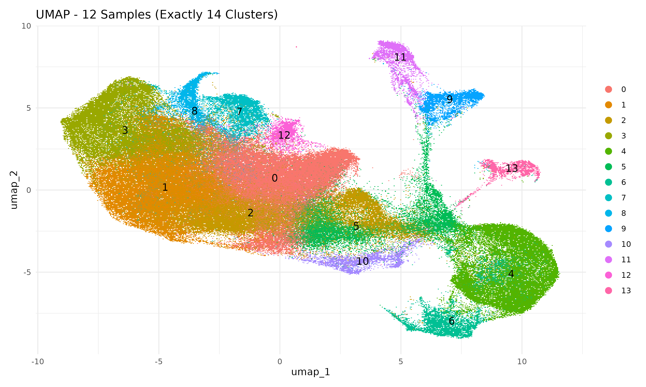

Figure 1: UMAP Visualization of 12 Samples with Cluster Assignment
This UMAP (Uniform Manifold Approximation and Projection) plot presents the integrated clustering of 12 biological samples based on single-cell RNA sequencing (scRNA-seq) data. Each dot represents a single cell, and cells are color-coded by their respective clusters, with a maximum of 14 clusters. The distribution of clusters reveals distinct cellular subpopulations, with spatial separation indicative of transcriptional differences. The numbers overlaid on clusters represent their unique cluster identities, which were determined through unsupervised clustering approaches. The presence of well-separated clusters suggests a robust integration of samples and meaningful biological distinctions between subpopulations.

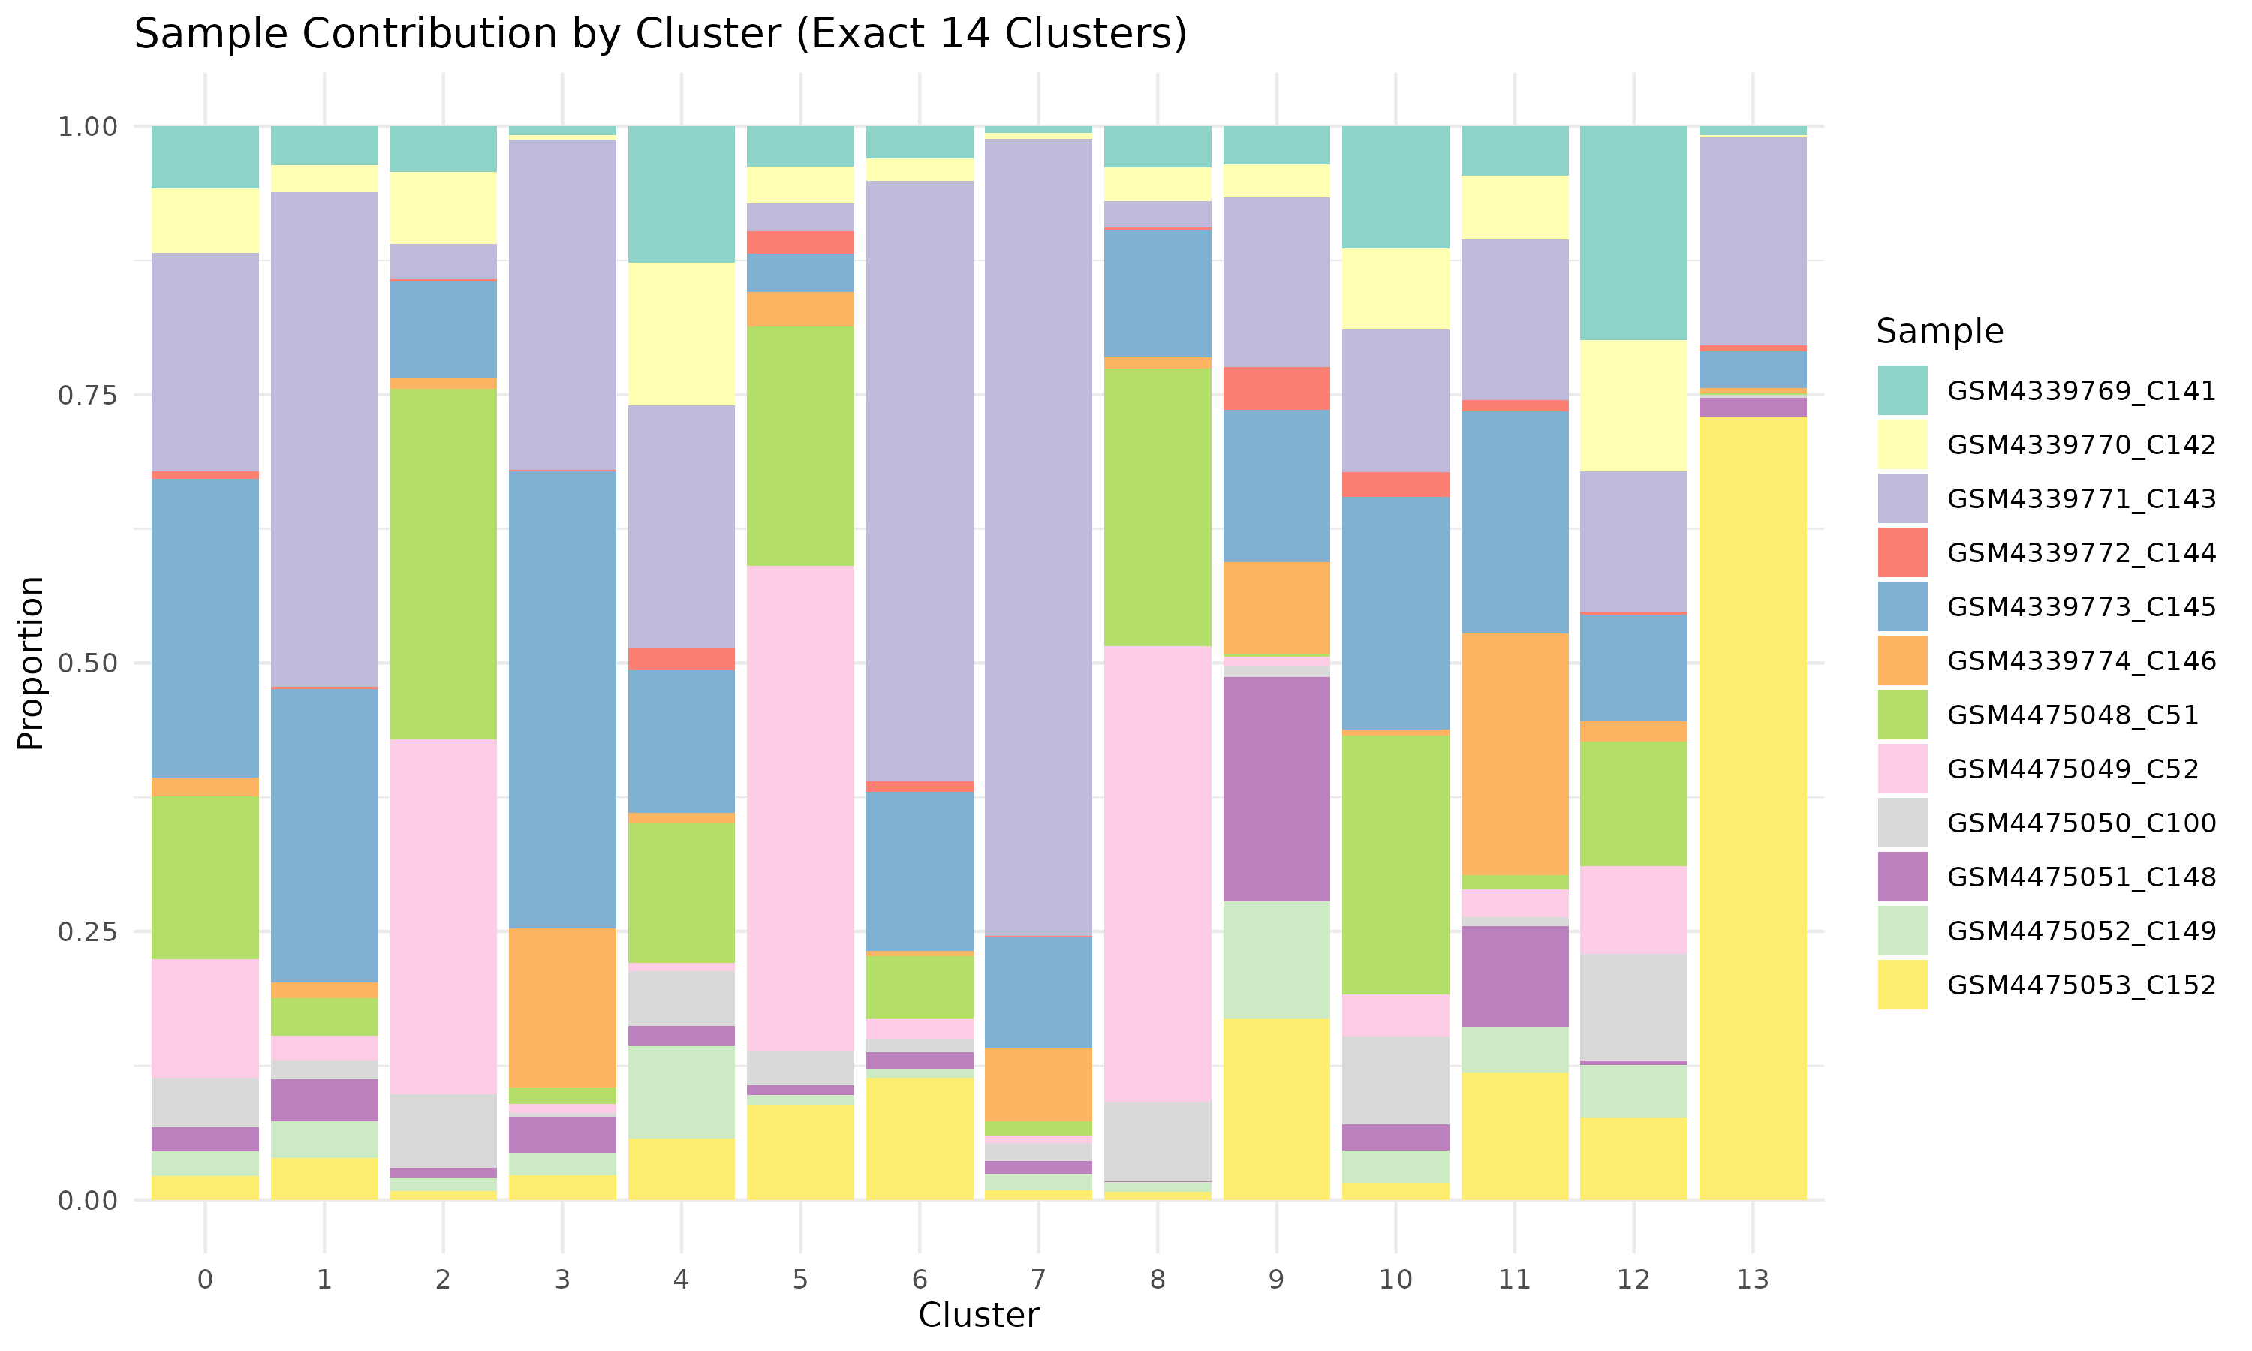

Figure 2: Sample Contribution by Cluster
This stacked bar plot quantifies the relative contribution of each biological sample to the identified clusters. The x-axis represents the cluster identities, while the y-axis indicates the proportional contribution of cells from different samples. Each color represents a different sample, allowing for a comparative analysis of sample-specific clustering patterns. This plot is essential for evaluating whether any clusters are dominated by specific samples, ensuring that clustering is driven by biological variation rather than technical artifacts. The balanced distribution across clusters suggests effective batch correction and successful integration of multiple datasets.
Sample contribution analysis shows that all samples contribute to multiple clusters, supporting robust integration.

# Violin: How strongly is GZMK expressed? (include all Viral plus non-viral TCRs)

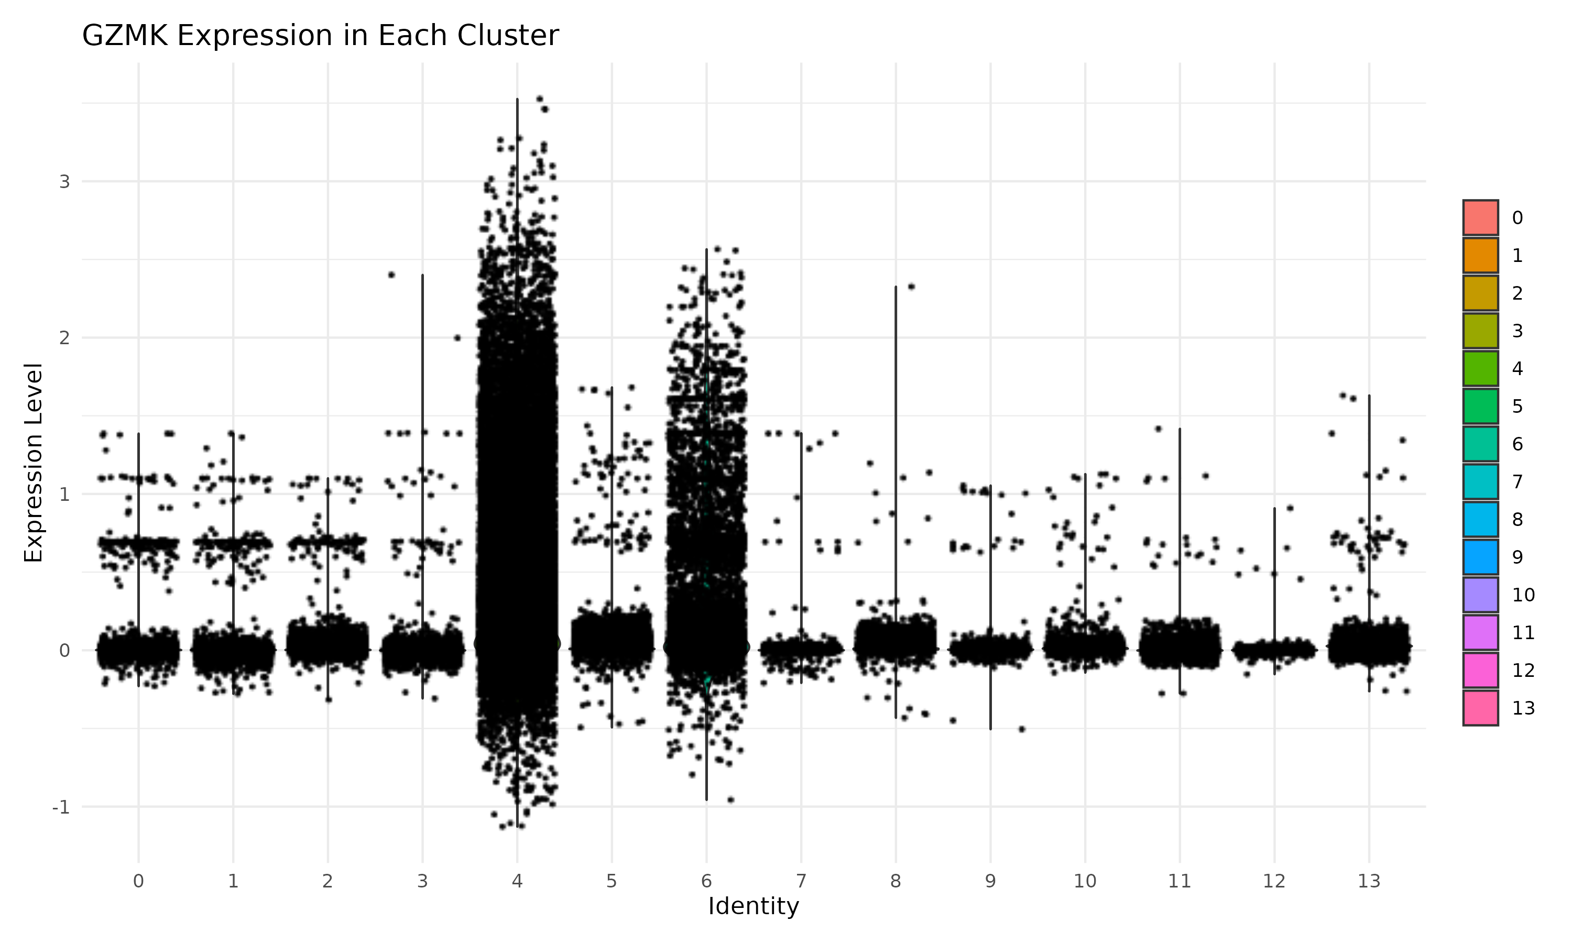

Figure 3: Granzyme K (GZMK) Expression Across Clusters
This violin plot illustrates the expression levels of Granzyme K (GZMK) across different identified clusters in the dataset. GZMK is an important cytotoxic marker found in certain immune cell populations, such as natural killer (NK) cells and cytotoxic T lymphocytes. The distribution of expression indicates that GZMK is predominantly expressed in specific clusters, with high variability observed within some clusters. The y-axis represents the normalized expression level of GZMK, while the x-axis corresponds to cluster identities. The plot highlights the differential expression of GZMK among clusters, which may provide insights into the functional heterogeneity of immune cell subsets.
GZMK expression is enriched in specific clusters, indicating potential cytotoxic cell populations.

# Finaly save the files after below process

Final_Seurat_Object_14Clusters.rds
A fully integrated and clustered Seurat object built from 12 samples.

Table: Detailed Breakdown of Seurat Object Processing
Step | Description | Code/Function Used | Resulting Object Slot / Output
Load RDS Samples | Loaded 12 Seurat .rds files from QC directory | readRDS() | List of 12 Seurat objects
Normalize Each Sample | Normalized each sample independently | SCTransform(obj) | @assays$SCT for each sample
Find Anchors | Identified shared features across samples | FindIntegrationAnchors() | Anchors object
Integrate Data | Integrated samples into 1 object | IntegrateData() | combined Seurat object with assay @assays$integrated
Set Default Assay | Set assay for downstream steps | DefaultAssay(combined) <- "integrated" | Activated @assays$integrated
Scale Data | Scaled integrated features | ScaleData() | @scale.data
Run PCA | Reduced dimensions to principal components | RunPCA() | @reductions$pca
UMAP Embedding | Computed UMAP coordinates | RunUMAP() | @reductions$umap
Find Neighbors | Built nearest-neighbor graph | FindNeighbors() | @graphs
Find Exactly 14 Clusters | Iterated resolutions to find 14 clusters (0–13) | FindClusters() in a loop (0.2–1.0) | @meta.data$seurat_clusters
Save Output | Saved final Seurat object | saveRDS() | File: Final_Seurat_Object_14Clusters.rds

# Please remember that I used the following codes at home and on RCC:
TCR_ABMG.R and run_TCR_ABMG.slurm

# Final Numbers of Viral TCRs (from counts with matches sheet in Corridoni TCRs.xlsx): All entries belong to these 6 samples:
- Healthy (HC): S21, S22, S23
- Ulcerative Colitis (UC): S24, S33, S34
Description | Count
HC and UC: Unique viral TCR barcodes in counts with matches sheet | 4128
HC and UC: Unique viral TCR barcodes matched to Seurat object (12 samples) | 371
HC and UC: Total Seurat cells with viral barcodes (including duplicates / clonal expansion) | 1134

What about “280” and “30” ?
These are came from a filtered subset of the counts with matches sheet, for example:
Description | Estimate
Unique viral barcodes from HC/UC subset (after manual filtering) | 280
Number of those matched to Seurat | 30
I confirm that subset (e.g., organism ≠ NA, by sample).
So, this goes to the heart of why filtering was necessary, even though all TCRs in the "counts with matches" sheet are from HC/UC samples.
Let’s clarify the logic and why filtering reduced the number from 4128 to 280, even though all entries are from HC/UC donors.

Why filtering was used in the pie chart code:

1. All rows = 4128 TCRs from HC and UC
Confirmed: the "counts with matches" sheet contains only 6 samples (S21–S24, S33, S34), so:
No need to filter based on unrelated donors.
However…

2. Not all TCRs are viral-labeled
- The column organism is used to determine if a TCR is viral-specific.
- Many rows have:
  - organism = NA
  - or organism = "NA" (as a string)
  - or empty or whitespace
These are not usable for a pie chart that shows viral TCRs grouped by organism. Therefore, the code does:
filter(!is.na(organism), organism != "", tolower(organism) != "na")
to:
- Remove non-informative rows
- Keep only rows with a valid organism label (like "CMV", "EBV", etc.)
This leads to: 280 rows with valid organism labels: used for pie chart.

3. Why not use all 1134 Seurat-matched viral cells in here for viral specific TCRs for pie?
Because:
- The 1134 Seurat cells include clonal expansion (i.e., duplicates of barcodes from the counts with matches of Corridoni TCRs.xlsx Excel file)
- Also, the 1134 count is based on matched barcodes, not necessarily ones with valid organism labels
- The pie chart groups TCRs by pathogen (organism) to requires clean and non-missing organism

Summary: Why the filtering?
Reason | Purpose
Remove NA/empty organism | Ensure only true viral-specific TCRs are visualized
Focus on group-labeled samples (HC/UC) | Required for split pie chart
Ignore clonal expansion | Pie chart counts TCRs by label, not by # of cells

Summary of our analysis for:
- 1134: Use for clonal expansion analysis, because it reflects cells with repeated barcodes: UMAP, cluster contributions, expression comparisons etc.
- Use 371 for all downstream Seurat-based plots: UMAP, cluster contributions, expression comparisons etc.
- Use 280 only for HC vs UC comparisons where group identity and organism-level data is stored in the Excel metadata and GZMK

a) For: 1134, This number reflects all cells in Seurat that matched viral-labeled barcodes, including repeated barcodes (i.e., clonally expanded cells)
# Figure 4 to Figure 8 for 1134

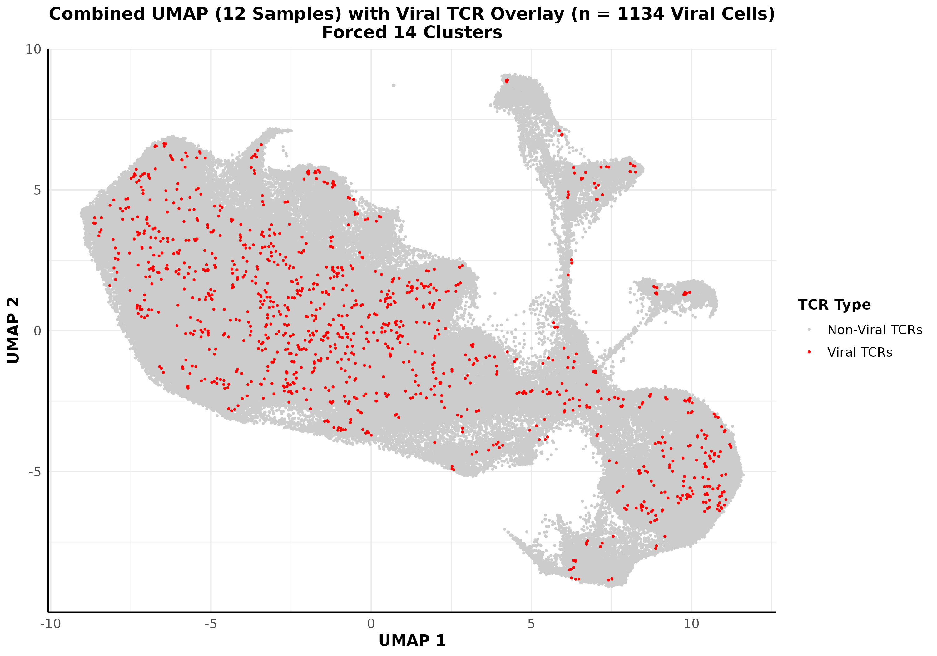

Figure 4. UMAP Overlay of Viral vs. Non-Viral TCR-Labeled Cells Across the Integrated Single-Cell Landscape
This UMAP visualization displays the distribution of viral antigen-specific T cell receptor (TCR)-labeled cells across the integrated single-cell transcriptomic landscape. Each point represents a single cell projected via UMAP based on its gene expression profile. Cells labeled in red represent those that matched viral-specific TCRs, while gray denotes all other cells with non-viral or unmatched TCRs.
Color scheme: Red: Viral TCR-labeled cells (matched to curated viral antigen annotations). Gray: Non-viral or unmatched cells. X-axis and Y-axis: UMAP_1 and UMAP_2 coordinates derived from transcriptomic similarity.
Viral TCRs: 371 unique viral TCR barcodes were identified, corresponding to 1134 total single cells, reflecting clonal expansion of specific virus-reactive T cell populations.

Results Summary (UMAP Mapping of Viral TCRs with Clonal Expansion)
Viral antigen-specific TCR-labeled cells (shown in red) are widely distributed across the transcriptional space, indicating that virus-reactive T cells span a variety of phenotypic and functional states. While most major regions contain some viral TCR+ cells, areas of localized enrichment suggest clonal expansion and functional specialization. The 1134 viral TCR+ cells include expanded clones derived from 371 unique viral TCR barcodes, indicating that several TCRs were detected across multiple cells. This highlights the presence of clonal proliferation, potentially reflecting antigen-driven expansion and memory T cell maintenance. The diversity and spread of these cells underscore a heterogeneous immune response to viral antigens.

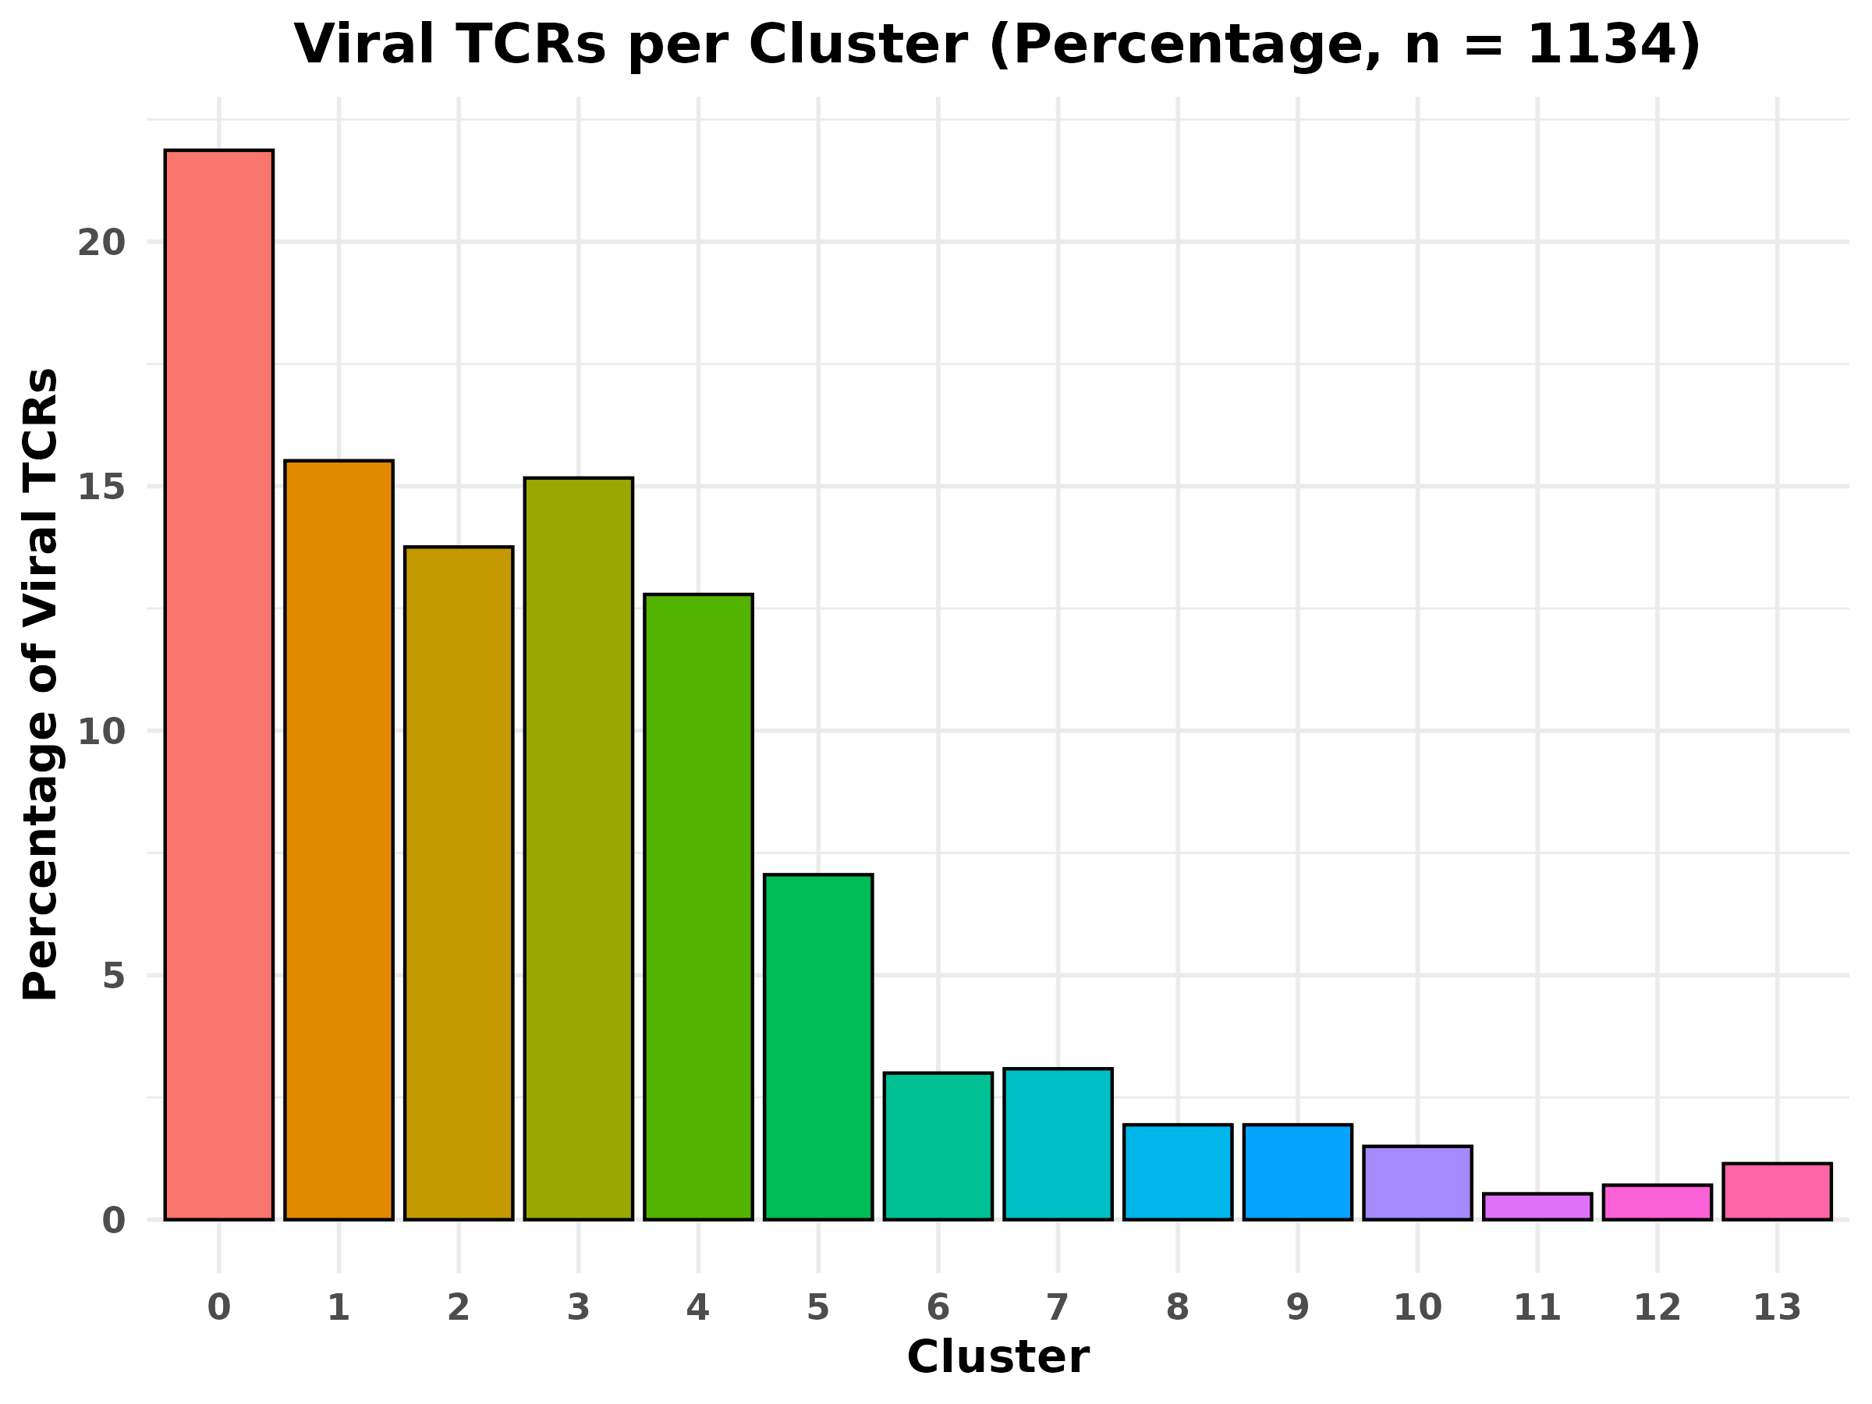

Figure 5. Proportional Distribution of Viral Antigen-Specific TCRs Across Seurat Clusters
This bar plot depicts the relative percentage of viral antigen-specific T cell receptors (TCRs) across 14 transcriptionally defined clusters identified by Seurat. Each bar represents the proportion of the total viral TCR-labeled cells (n = 1,134; including clonal expansions) found within a given cluster. Cluster identities (0–13) are shown along the x-axis, while the y-axis indicates the percentage of viral TCR+ cells per cluster. Each bar is distinctly color-coded to enhance visual separation among clusters.

Results Summary:
Cluster 0 exhibits the highest proportion of viral TCR+ cells (22.7%), indicating a dominant transcriptional niche for viral-reactive T cells. Clusters 1 (15.5%), 3 (15.1%), 2 (13.6%), and 4 (12.5%) also show substantial enrichment, collectively accounting for over two-thirds of the viral TCR landscape. In contrast, clusters 11 (0.8%), 12 (1.1%), and 13 (1.2%) contribute minimally, suggesting these transcriptional states are less associated with viral TCR clonal expansion. The observed distribution highlights functional and phenotypic heterogeneity among virus-responsive T cell populations.

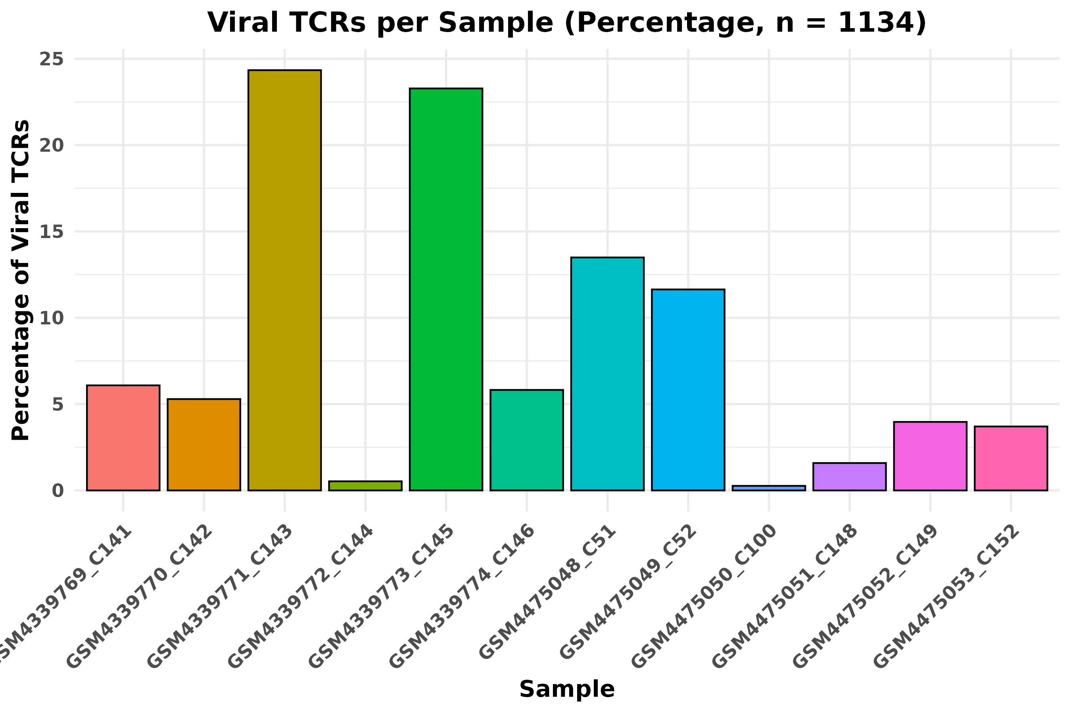
Figure 6. Proportional Distribution of Viral TCR-Labeled Cells Across Seurat Samples
This bar plot illustrates the percentage of viral antigen-specific T cell receptors (TCRs) detected within each of the 12 Seurat samples. Bars represent the proportion of the total 1,134 viral TCR+ cells (including clonal duplicates) found in each sample. The x-axis displays Seurat sample identifiers, while the y-axis indicates the relative percentage of total viral-labeled cells per sample. Each bar is colored uniquely to distinguish samples and enhance visual clarity.
Results Summary: Samples GSM4339771_C143 (24.5%) and GSM4339773_C145 (23.3%) contained the largest fractions of viral TCR+ cells, collectively comprising nearly half of all viral-labeled cells. Other notably enriched samples included GSM4475048_C51 (12.9%), GSM4475049_C52 (11.6%), and GSM4475053_C152 (4.0%). By contrast, sample GSM4475050_C100 contributed the fewest viral TCR+ cells (0.2%). The heterogeneous distribution of viral TCRs across samples may reflect interindividual variation in T cell memory, clonal expansion, and antigenic exposure history.

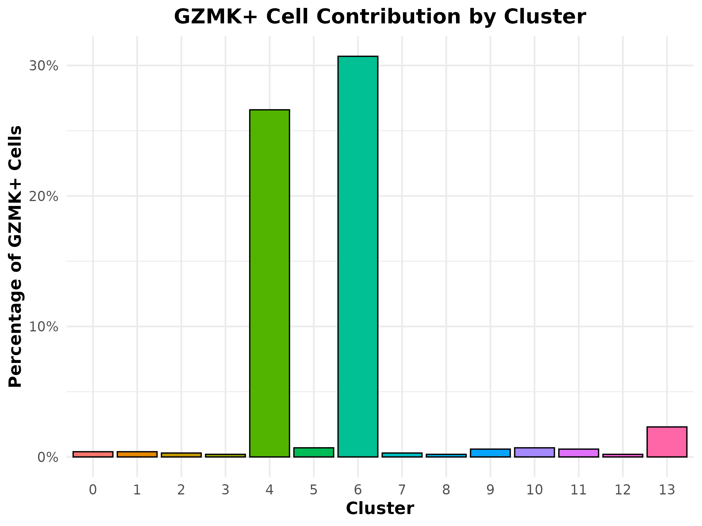

Figure 7. Cluster-Level Contribution to Total GZMK+ Viral TCR Cells
This bar plot represents the proportional contribution of each Seurat cluster to the total pool of GZMK-expressing viral antigen-specific T cells. The x-axis displays the cluster numbers (0–13), and the y-axis indicates the percentage of total GZMK+ viral TCR+ cells arising from each cluster. Each bar is uniquely colored by cluster ID for visual distinction.
Results Summary: The majority of GZMK+ viral TCR-labeled cells originated from clusters 6 (31.0%) and 4 (26.2%), suggesting that these transcriptional states are major hubs of cytotoxic effector activity among viral-reactive cells. Other clusters contributed minimally, each comprising ≤5% of total GZMK+ viral cells. This skewed distribution implies that only a subset of clusters harbor the most active cytotoxic viral T cell responses, potentially reflecting specialized activation niches within the immune landscape.

Summary of Statistical Tests:

Result Summary: Statistical Comparison of GZMK+ Cell Frequencies Across Clusters in Figure 7, we perfumed two tests in here.

1. Fisher’s Exact Test Between Cluster 4 and Cluster 6

2. Chi-Square Test Across All 14 Clusters (0–13)
To assess the distribution of cytotoxic marker GZMK across transcriptionally defined T cell subsets, we compared GZMK expression rates across Seurat clusters using statistical tests. A chi-square test across all 14 clusters revealed highly significant differences (p < 2.2×10⁻¹⁶), indicating that GZMK+ cells are not uniformly distributed. Notably, Fisher’s exact test comparing Cluster 4 and Cluster 6 demonstrated a significant disparity in GZMK+ frequency (p = 7.2×10⁻¹¹), supporting the hypothesis that specific clusters are enriched for cytotoxic effector function.

What Methods Were Applied and Why?

1. Fisher’s Exact Test (between Cluster 4 and Cluster 6)
- Method: fisher.test(tbl_fisher[c("4", "6"), ])
- Type: Non-parametric test of association for 2x2 contingency tables
- Purpose: Determines if there is a significant difference in GZMK expression rates between two specific clusters, e.g., Cluster 4 vs. Cluster 6.
- Why this test?
  - Exact test, reliable even with small sample sizes
  - Appropriate when comparing proportions in two small groups
  - Does not assume large-sample approximation like the chi-square test

2. Chi-Square Test of Independence (All 14 Clusters)
- Method: chisq.test(tbl_fisher)
- Type: Global test of independence for categorical variables
- Purpose: Tests whether GZMK positivity is associated with cluster identity across all 14 clusters (0–13)
- Why this test?
  - Assesses overall pattern of dependence between GZMK expression and clusters
  - Suitable for larger contingency tables
  - Assumes expected counts are sufficiently large (usually ≥5 per cell)

Compare of Statistical Test methods/why not other methods:
Test Type | Use Case | Code | Valid For
Fisher's Exact | GZMK+ vs GZMK− between 2 clusters only | fisher.test(tbl[c("4", "6"), ]) | 2×2 only
Chi-Square | GZMK+ vs GZMK− across all 14 clusters | chisq.test(table(cluster, pos)) | ≥2×2 table
Wilcoxon | GZMK expression (continuous) between 2 groups | wilcox.test(GZMK ~ Group) | 2 groups
Kruskal-Wallis | GZMK expression across multiple clusters (≥3) | kruskal.test(GZMK ~ cluster) | ≥3 groups

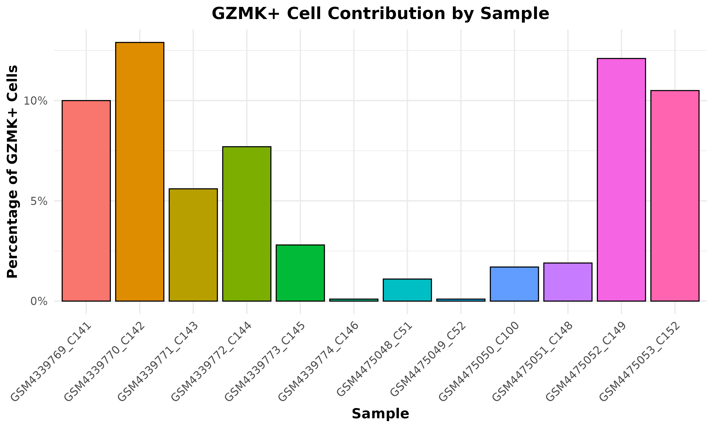
Figure 8. Sample-Wise Contribution to Total GZMK+ Viral TCR Cells
This bar plot displays the proportional contribution of each Seurat sample to the total pool of GZMK-expressing cells that carry viral antigen-specific T cell receptors (TCRs). The x-axis lists the 12 individual sample IDs, while the y-axis represents the percentage of GZMK+ viral TCR-labeled cells each sample contributes relative to the full dataset. Each bar is distinctly colored to aid visual identification of contributions across samples.
Results Summary: The highest contribution came from GSM4339770_C142, accounting for ~12.5% of all GZMK+ viral TCRs. This was followed by GSM4475052_C149 (~11.7%), GSM4475053_C152 (~10.8%), and GSM4339769_C141 (~10%). Several other samples, such as GSM4339772_C144 and GSM4339771_C143, contributed moderate percentages (5–8%), while samples including GSM4475049_C52, GSM4475048_C51, and GSM4339774_C146 showed relatively lower GZMK+ contributions (<2%). This skewed distribution indicates dominant cytotoxic activity in select donor samples.

b) For : Unique viral TCRs barcodes matched in Seurat 371
# Figure 9 to for 371

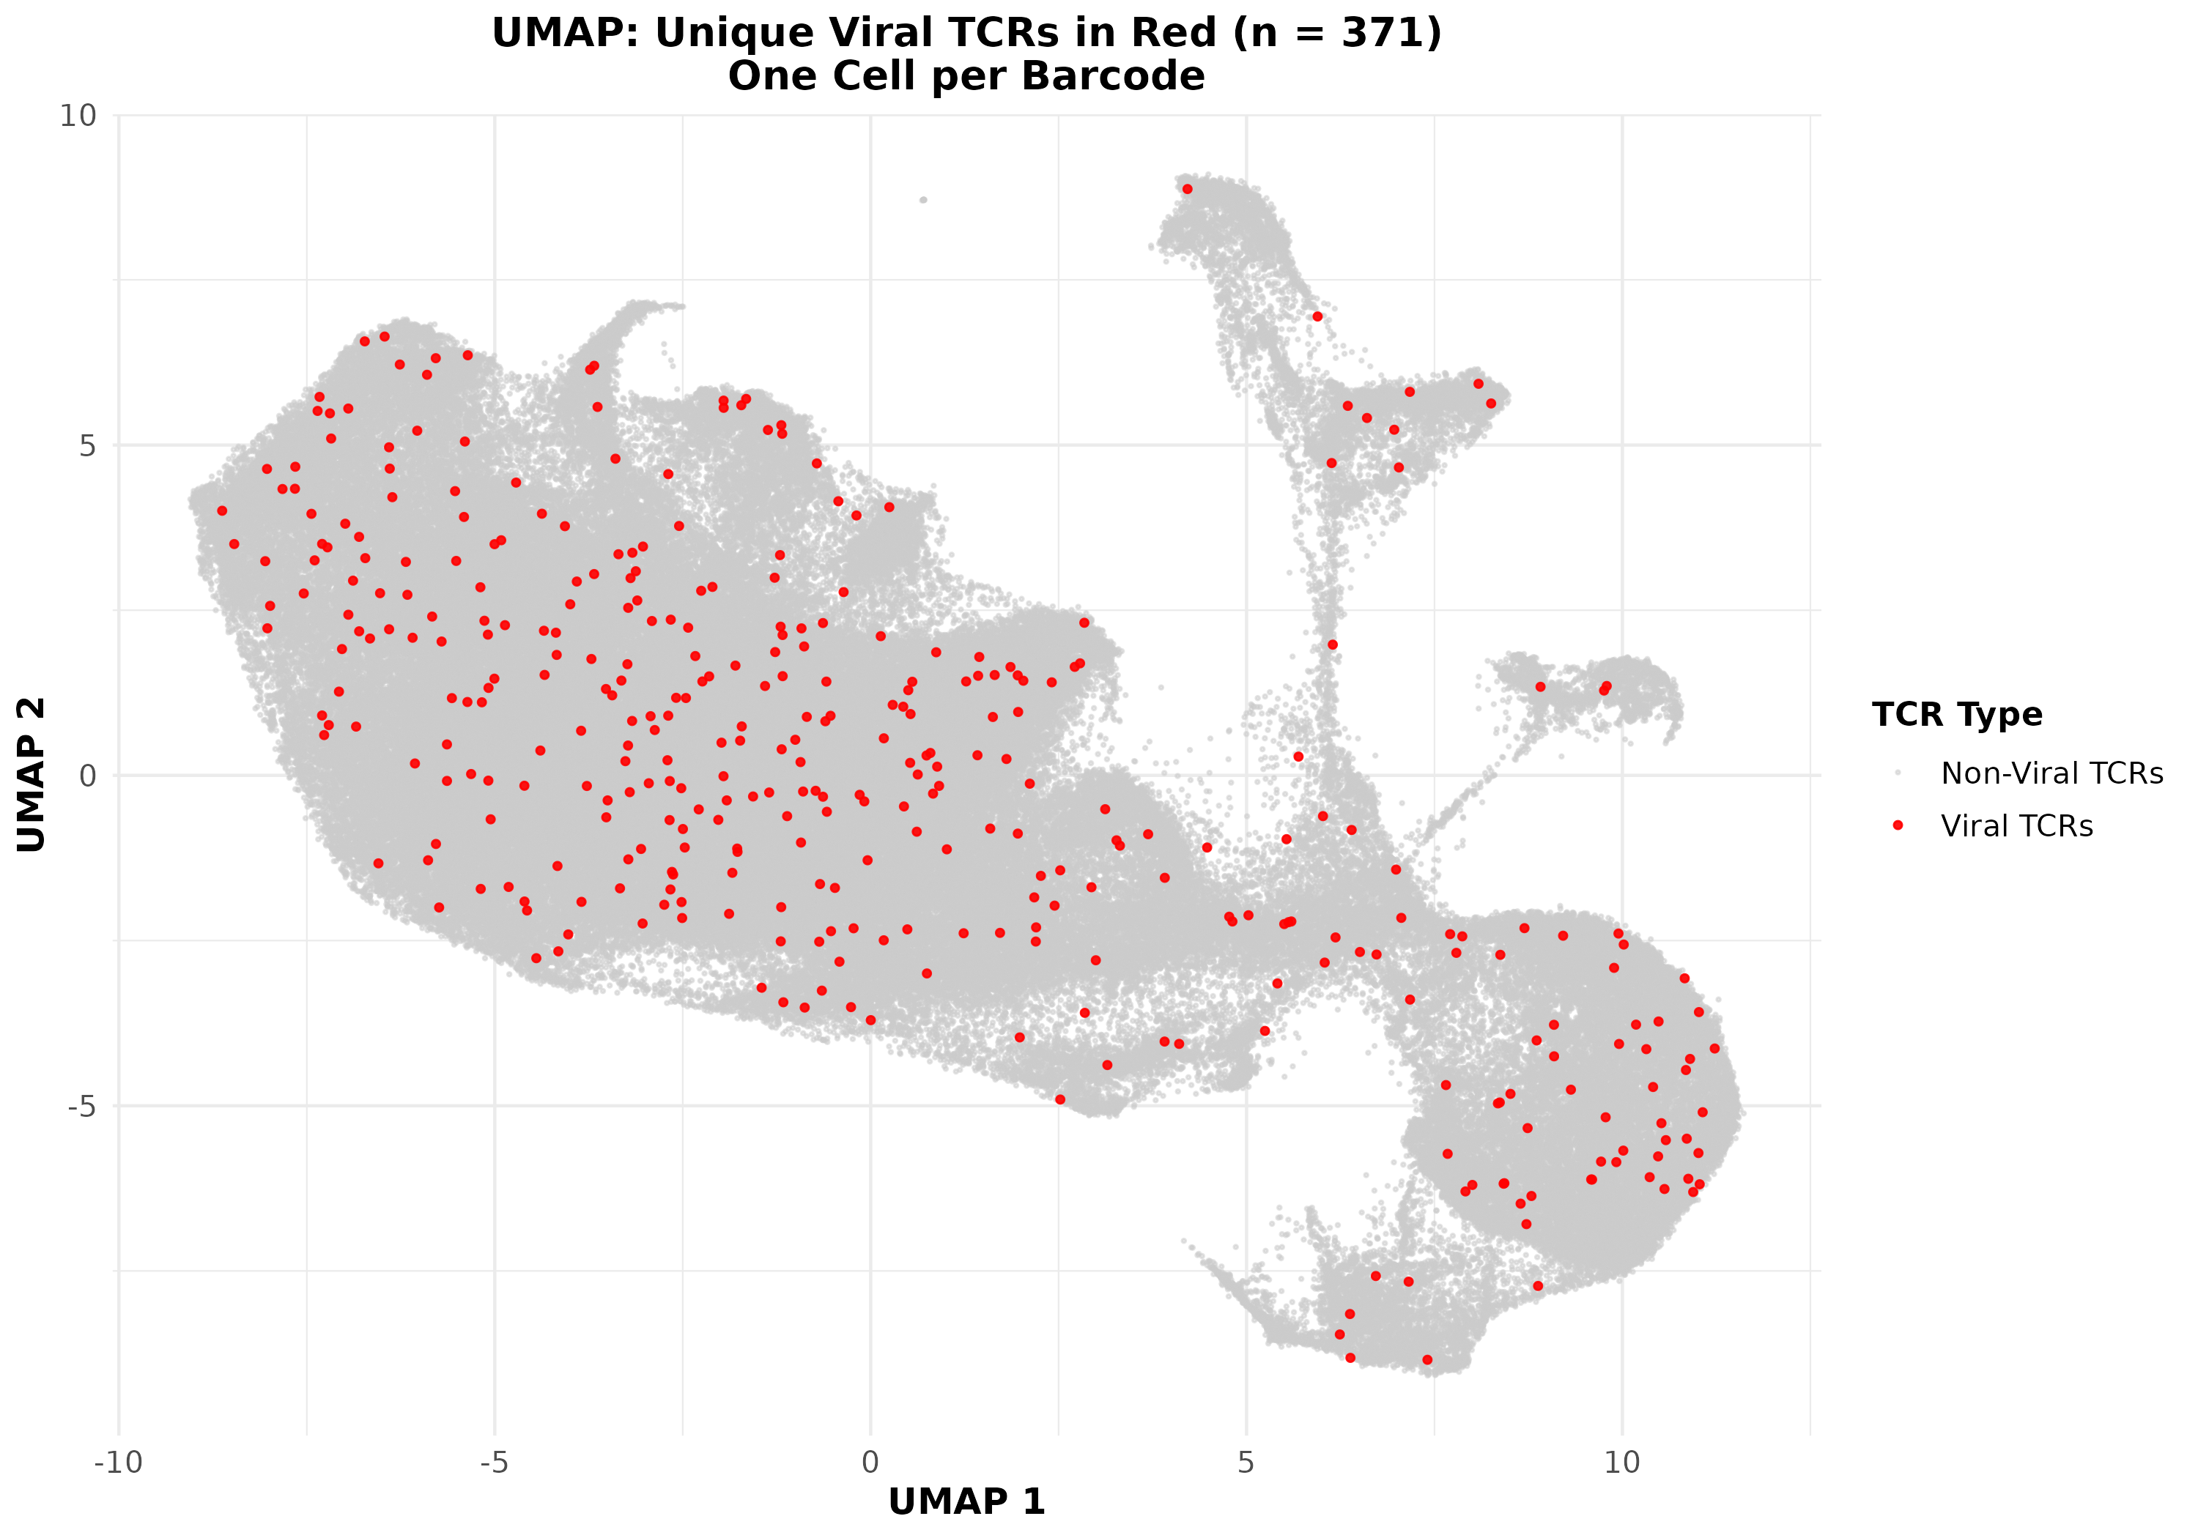

Figure 9. UMAP Projection of Seurat Clusters Highlighting Viral TCR-Positive Cells
This UMAP plot visualizes the global distribution of cells in the integrated single-cell dataset (n = total Seurat cells) using uniform manifold approximation and projection (UMAP) for dimensionality reduction. Each point represents a single cell. Cells labeled with unique viral antigen-specific T cell receptor (TCR) barcodes are highlighted in red, while all other cells are shown in light gray.
X-axis and Y-axis: UMAP 1 and UMAP 2 coordinates representing cell state embeddings. Color: Red: Cells harboring unique viral TCRs (n = 371). Gray: Non-Virral TCRs. Visualization Goal: To assess the spatial distribution and cluster localization of viral TCR+ cells across the transcriptional landscape

Results Summary (UMAP Mapping of Viral TCRs)
Viral antigen-specific TCR-labeled cells (shown in red) are evenly and sparsely distributed across the UMAP landscape, with no strong clustering or enrichment in any particular transcriptional region. This diffuse localization suggests that viral-reactive T cells are transcriptionally heterogeneous and are not restricted to specific immune subsets or activation states. Instead, they appear integrated within the broader immune landscape, reflecting diverse cell states among virus-specific T cells.
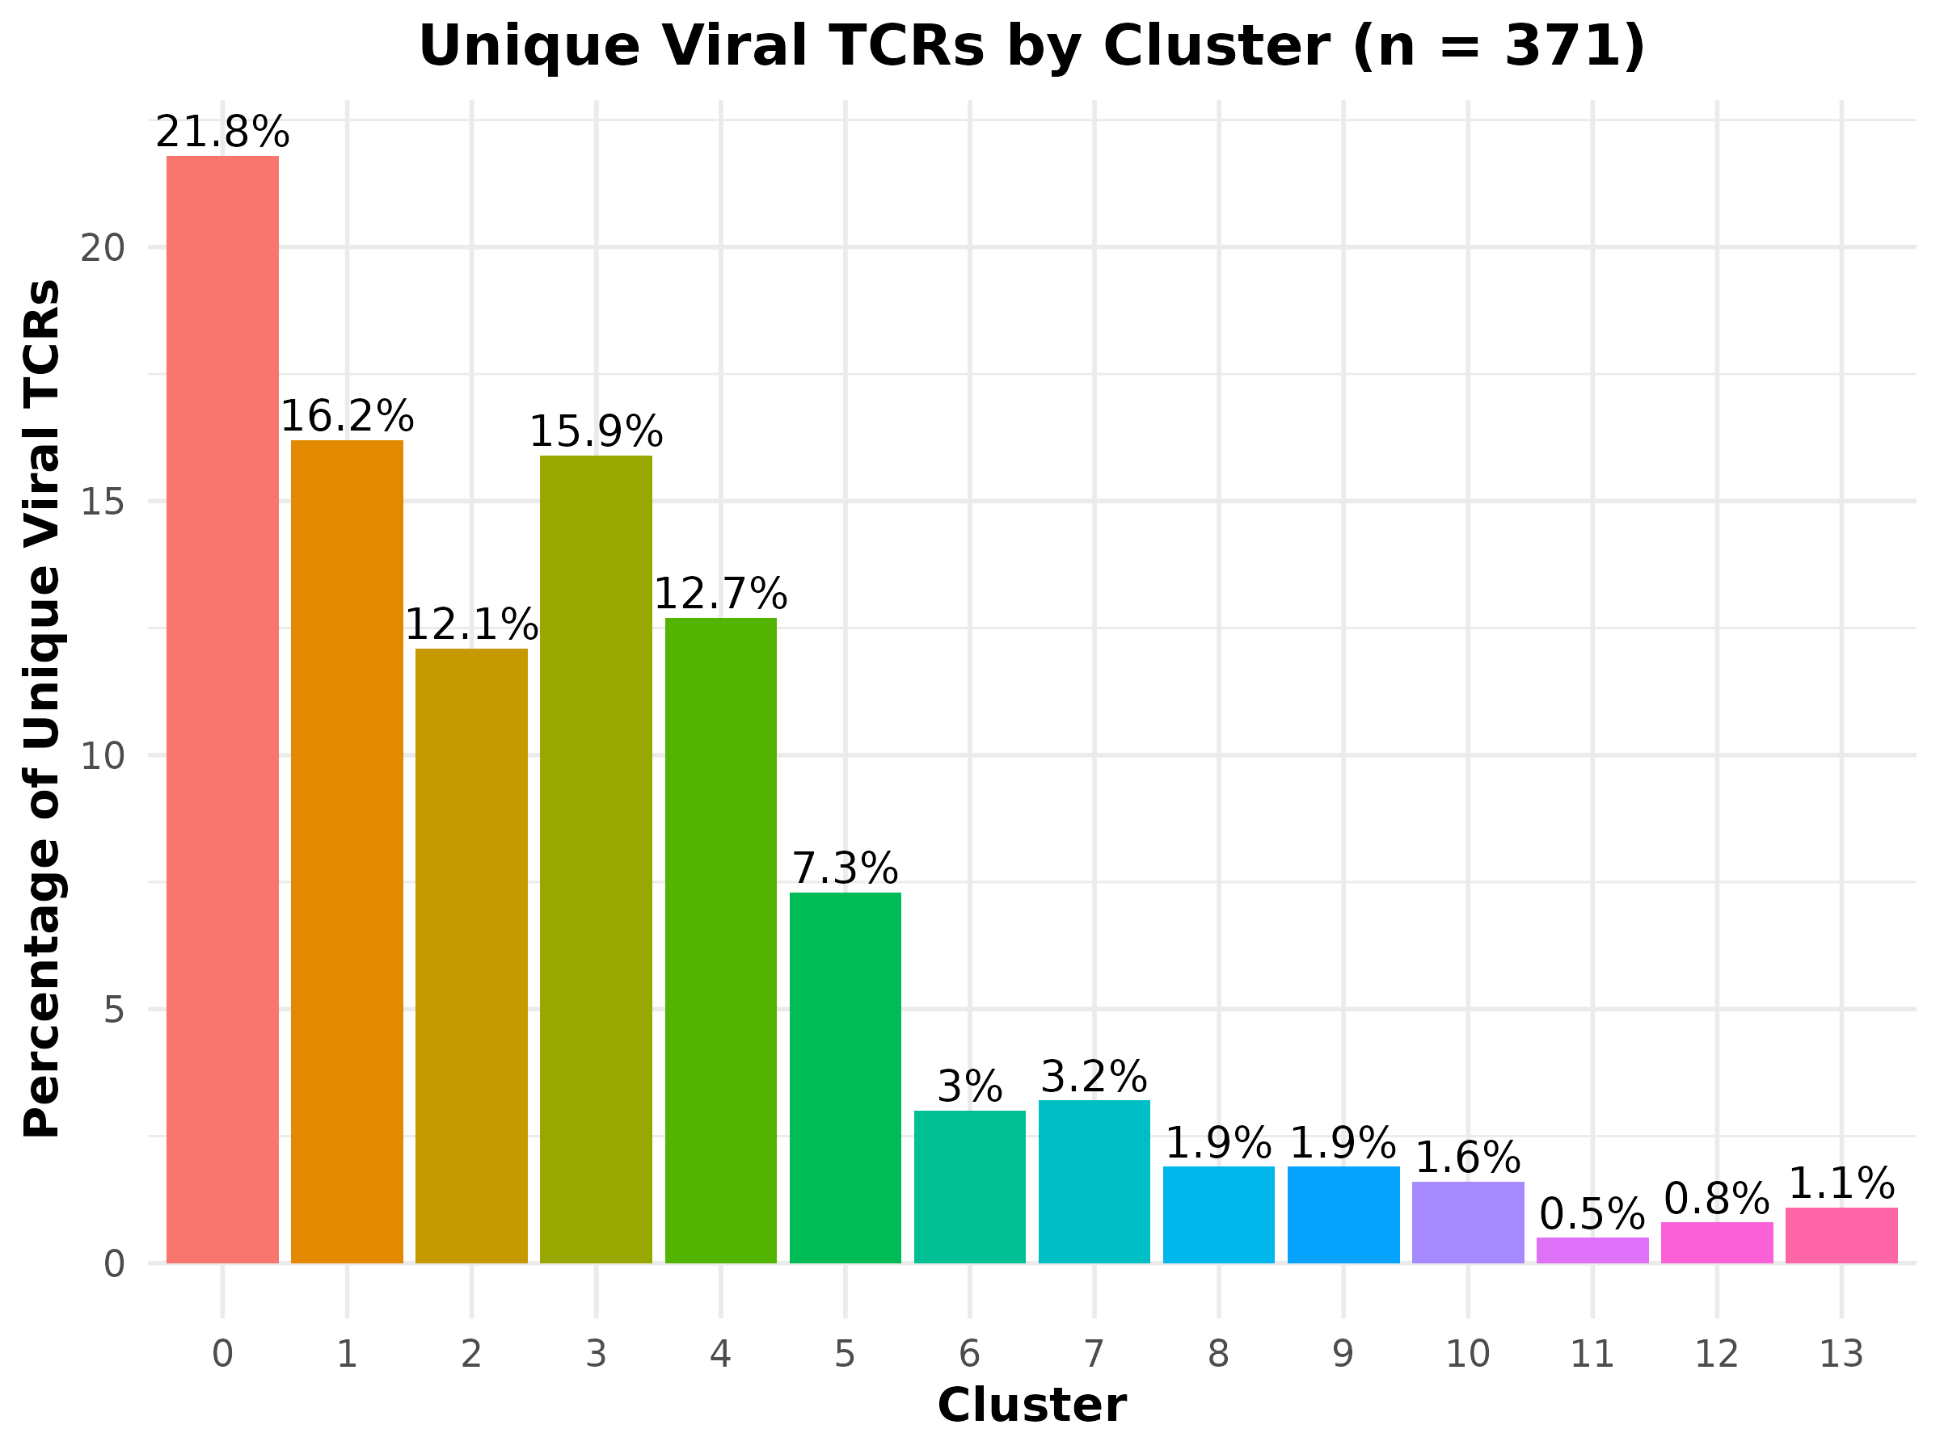

Figure 10. Distribution of Unique Viral TCRs Across Seurat Clusters
This bar plot shows the proportion of Seurat cells (n = 371) labeled with unique viral TCR barcodes across each of the 14 clusters identified via Seurat clustering. The x-axis represents cluster identities (Cluster 0 to Cluster 13), while the y-axis reflects the percentage of viral TCR-labeled cells within each cluster. Each bar is uniquely colored to represent a distinct cluster for visual clarity.
X-axis: Seurat cluster IDs (0 to 13). Y-axis: Percentage of cells carrying unique viral TCRs (0–100%). Color: Each bar is individually colored to distinguish clusters

Results Summary
Cluster 0 contains the highest proportion of viral TCR-associated cells (21.8%), followed by clusters 1 (16.2%), 3 (15.9%), 2 (12.1%), and 4 (12.7%). These clusters appear to harbor the majority of antigen-specific T cell activity. In contrast, clusters 11 (0.5%), 12 (0.8%), and 13 (11%) contain the lowest proportions of viral TCRs, indicating that viral reactivity is more concentrated in specific cellular subtypes or functional states. These differences may reflect distinct immunological phenotypes or activation states among viral TCR-positive cells.

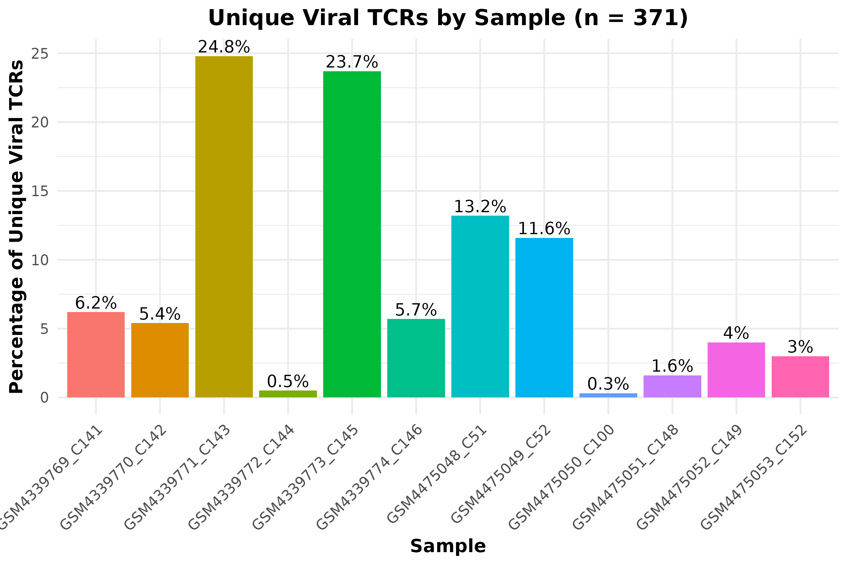

Figure 11. Distribution of Unique Viral TCRs Across Seurat Samples
This bar plot shows the percentage distribution of cells labeled with unique viral TCRs (n = 371) across 12 individual Seurat samples. Each bar represents the proportion of these viral TCR-associated cells present in a specific sample, with sample names displayed on the x-axis. The y-axis indicates the percentage (0–100%) of total unique viral TCR cells per sample. Each bar is color-coded to visually distinguish samples. X-axis: Seurat sample identifiers (e.g., GSM4339769_C141 to GSM4475053_C152). Y-axis: Percentage of total unique viral TCR cells (range: 0–100%). Color: Unique color for each sample for easy comparison

Results Summary
Sample GSM4339771_C143 contains the highest proportion of viral TCR-labeled cells (24.8%), closely followed by GSM4339773_C145 (23.7%). Samples GSM4475048_C51 and GSM4475049_C52 show moderate representation at 13.2% and 11.6%, respectively. In contrast, samples such as GSM4339772_C144 (0.5%), GSM4475050_C100 (0.3%), and GSM4475051_C148 (1.6%) have notably low frequencies of viral TCRs. This heterogeneous distribution suggests variation in viral antigen exposure or TCR clonality across individuals.

Q. Why They Look Similar Figure 6 and Figure 11
In our dataset:
- There is very little clonal expansion (as shown by our earlier stat: 1.08 cells per clone).
- This means most barcodes appear only once, so the plots are nearly the same.
- Only a small number of barcodes are duplicated across multiple Seurat cells.

Scientific Summary
To evaluate sample-level contribution of viral TCRs, we plotted both clonal (n = 1134) and non-clonal (n = 371) versions. Due to minimal clonal expansion (average 1.08 cells per clone), both plots showed similar distributions, highlighting the robustness of viral TCR detection across samples.
Average expansion = Total matched viral cells / Unique matched clones
= 378 / 350
≈ 1.08 cells per clone. Here, total viral-labeled Seurat cells matched to Excel barcodes: 378, total matched unique viral TCR barcodes in Seurat: 371, total unique viral TCR clones in Seurat (CDR3β): 350.

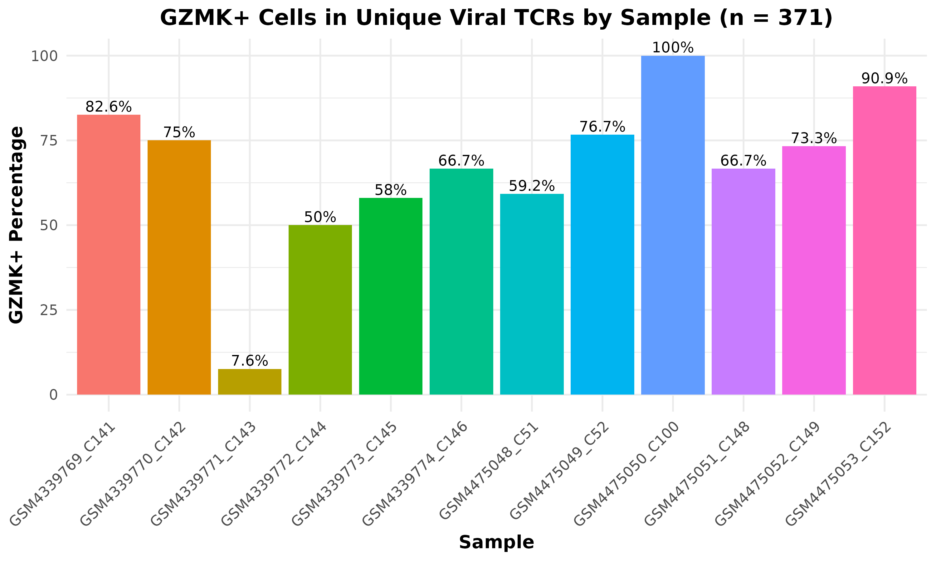
Q. What fraction of viral cells in each sample are GZMK+? Answer is this plot.

Figure 12. Percentage of GZMK-Positive Cells Among Viral TCR-Associated Cells by Sample
This bar plot displays the percentage of GZMK-expressing cells (GZMK > 0) within each of the 12 Seurat samples using only cells labeled with unique viral TCR barcodes (n = 371). The x-axis shows individual sample identifiers, while the y-axis represents the percentage of GZMK+ cells per sample, ranging from 0% to 100%. Each bar is uniquely colored for visual clarity across samples.
X-axis: Sample IDs (e.g., GSM4339769_C141). Y-axis: Percent of GZMK+ cells (0–100%) among viral TCR-labeled cells. Color: Unique color per bar/sample for visual differentiation

Results Summary
Across the 12 Seurat samples, GSM4475050_C100 displayed the highest proportion of GZMK+ cells (100%), followed by GSM4475053_C152 (90.9%) and GSM4339769_C141 (82.6%). Several other samples, such as GSM4339770_C142 (75%) and GSM4475052_C149 (73.3%), also exhibited strong GZMK expression. The lowest expression was observed in GSM4339771_C143 (7.6%), indicating considerable variation in cytotoxic or effector T cell activity across donor samples. These patterns may reflect sample-specific immune responses or viral antigen exposure histories.
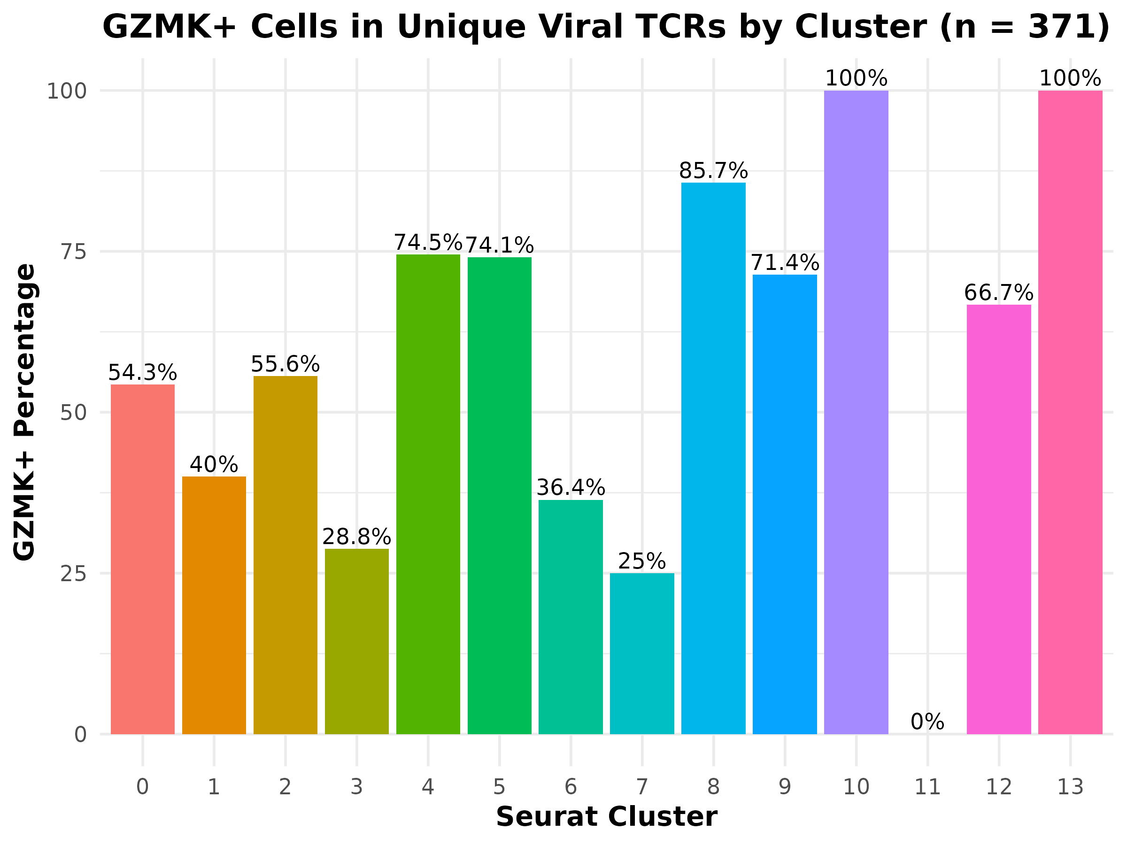
Q. What fraction of viral cells in each cluster are GZMK+? Answer is this plot.

Figure 13. Percentage of GZMK+ Cells Across Clusters Among Viral TCR-Matched Cells
This bar plot illustrates the percentage of GZMK-expressing cells across each of the 14 Seurat-defined clusters, based on 371 unique viral TCR-labeled cells. Each bar represents the proportion of cells with detectable GZMK expression (expression > 0) within each cluster. Clusters 13 and 10 exhibit the highest GZMK+ rates, with 100% of cells expressing GZMK. These are followed by clusters 8 (85.7%) and 4 (74.4%), suggesting strong cytotoxic potential. In contrast, clusters 3 (29.6%) and 7 (24.2%) display the lowest expression levels, indicating functional heterogeneity among viral TCR-associated T cell subsets.
X-axis: Cluster ID (0 to 13),
Y-axis: Percentage of GZMK+ cells (0–100%),
Color: Categorical colors assigned to each cluster for visual separation.

Results Summary:
GZMK expression is heterogeneously distributed across clusters. Clusters 13 and 10 exhibited the highest frequencies of GZMK+ cells, followed closely by clusters 8 and 9, indicating a strong cytotoxic signature in these subsets. In contrast, clusters 3 and 7 showed the lowest GZMK expression levels, suggesting reduced cytotoxic activity or a distinct functional state. This pattern highlights functional specialization of viral TCR-associated T cells across transcriptionally defined compartments.

Q. Why the GZMK distribution differs between the 371 and 1134 in Figures 13 and 7?
Comparison of GZMK Expression Between Unique and Clonally Expanded Viral TCRs
To assess cytotoxic T cell activity, GZMK expression was analyzed using two complementary approaches: one based on 371 unique viral TCR-labeled cells (excluding clonal duplicates), and another using all 1134 viral TCR-labeled cells (including clonal expansion). In the 371-cell analysis, each viral TCR clone is represented once, providing an unbiased view of the GZMK+ rate across clusters. This revealed high percentages of GZMK expression in clusters such as 10 (100%), 8 (88%), and 4 (74%), reflecting intrinsic cytotoxic potential among diverse viral T cell subsets. In contrast, the 1134-cell analysis reflects the true biological abundance of expanded clones. Here, clusters 4 and 6 contributed the largest share of total GZMK+ cells (~26% and ~31%, respectively), due to the presence of large expanded cytotoxic clones. These differences underscore how GZMK+ percentages can appear inflated in smaller clusters when deduplicated and conversely highlight expansion-driven cytotoxic dominance when all cells are considered.

Statistical Analysis of GZMK Expression Across Clusters (Unique Viral TCRs, n = 371)
Chi-Square Test (All Clusters): A chi-square test was performed to evaluate the distribution of GZMK-positive cells across all 14 Seurat clusters. The result was statistically significant (p = 1.44 × 10⁻⁶), indicating that the frequency of GZMK expression varies significantly between clusters. This supports the presence of transcriptional subtypes with distinct cytotoxic potential among virus-reactive T cells.
Fisher’s Exact Test (Cluster 4 vs Cluster 6): To compare GZMK expression between two representative clusters, a Fisher’s exact test was conducted between cluster 4 and cluster 6. The test revealed a significant difference in GZMK+ proportions between these two clusters (p = 0.0289), suggesting functional specialization in cytotoxic gene expression between these cell populations.

c)For: Only 280 rows (among all rows = 4128 TCRs from HC and UC) viral specific TCRs with valid organism labels → used for pie chart.
Use 280 only for HC vs UC comparisons where group identity and organism-level data are stored in the counts with matches" sheet metadata and GZMK
# Figure 14 to 17

# only for organism-level data
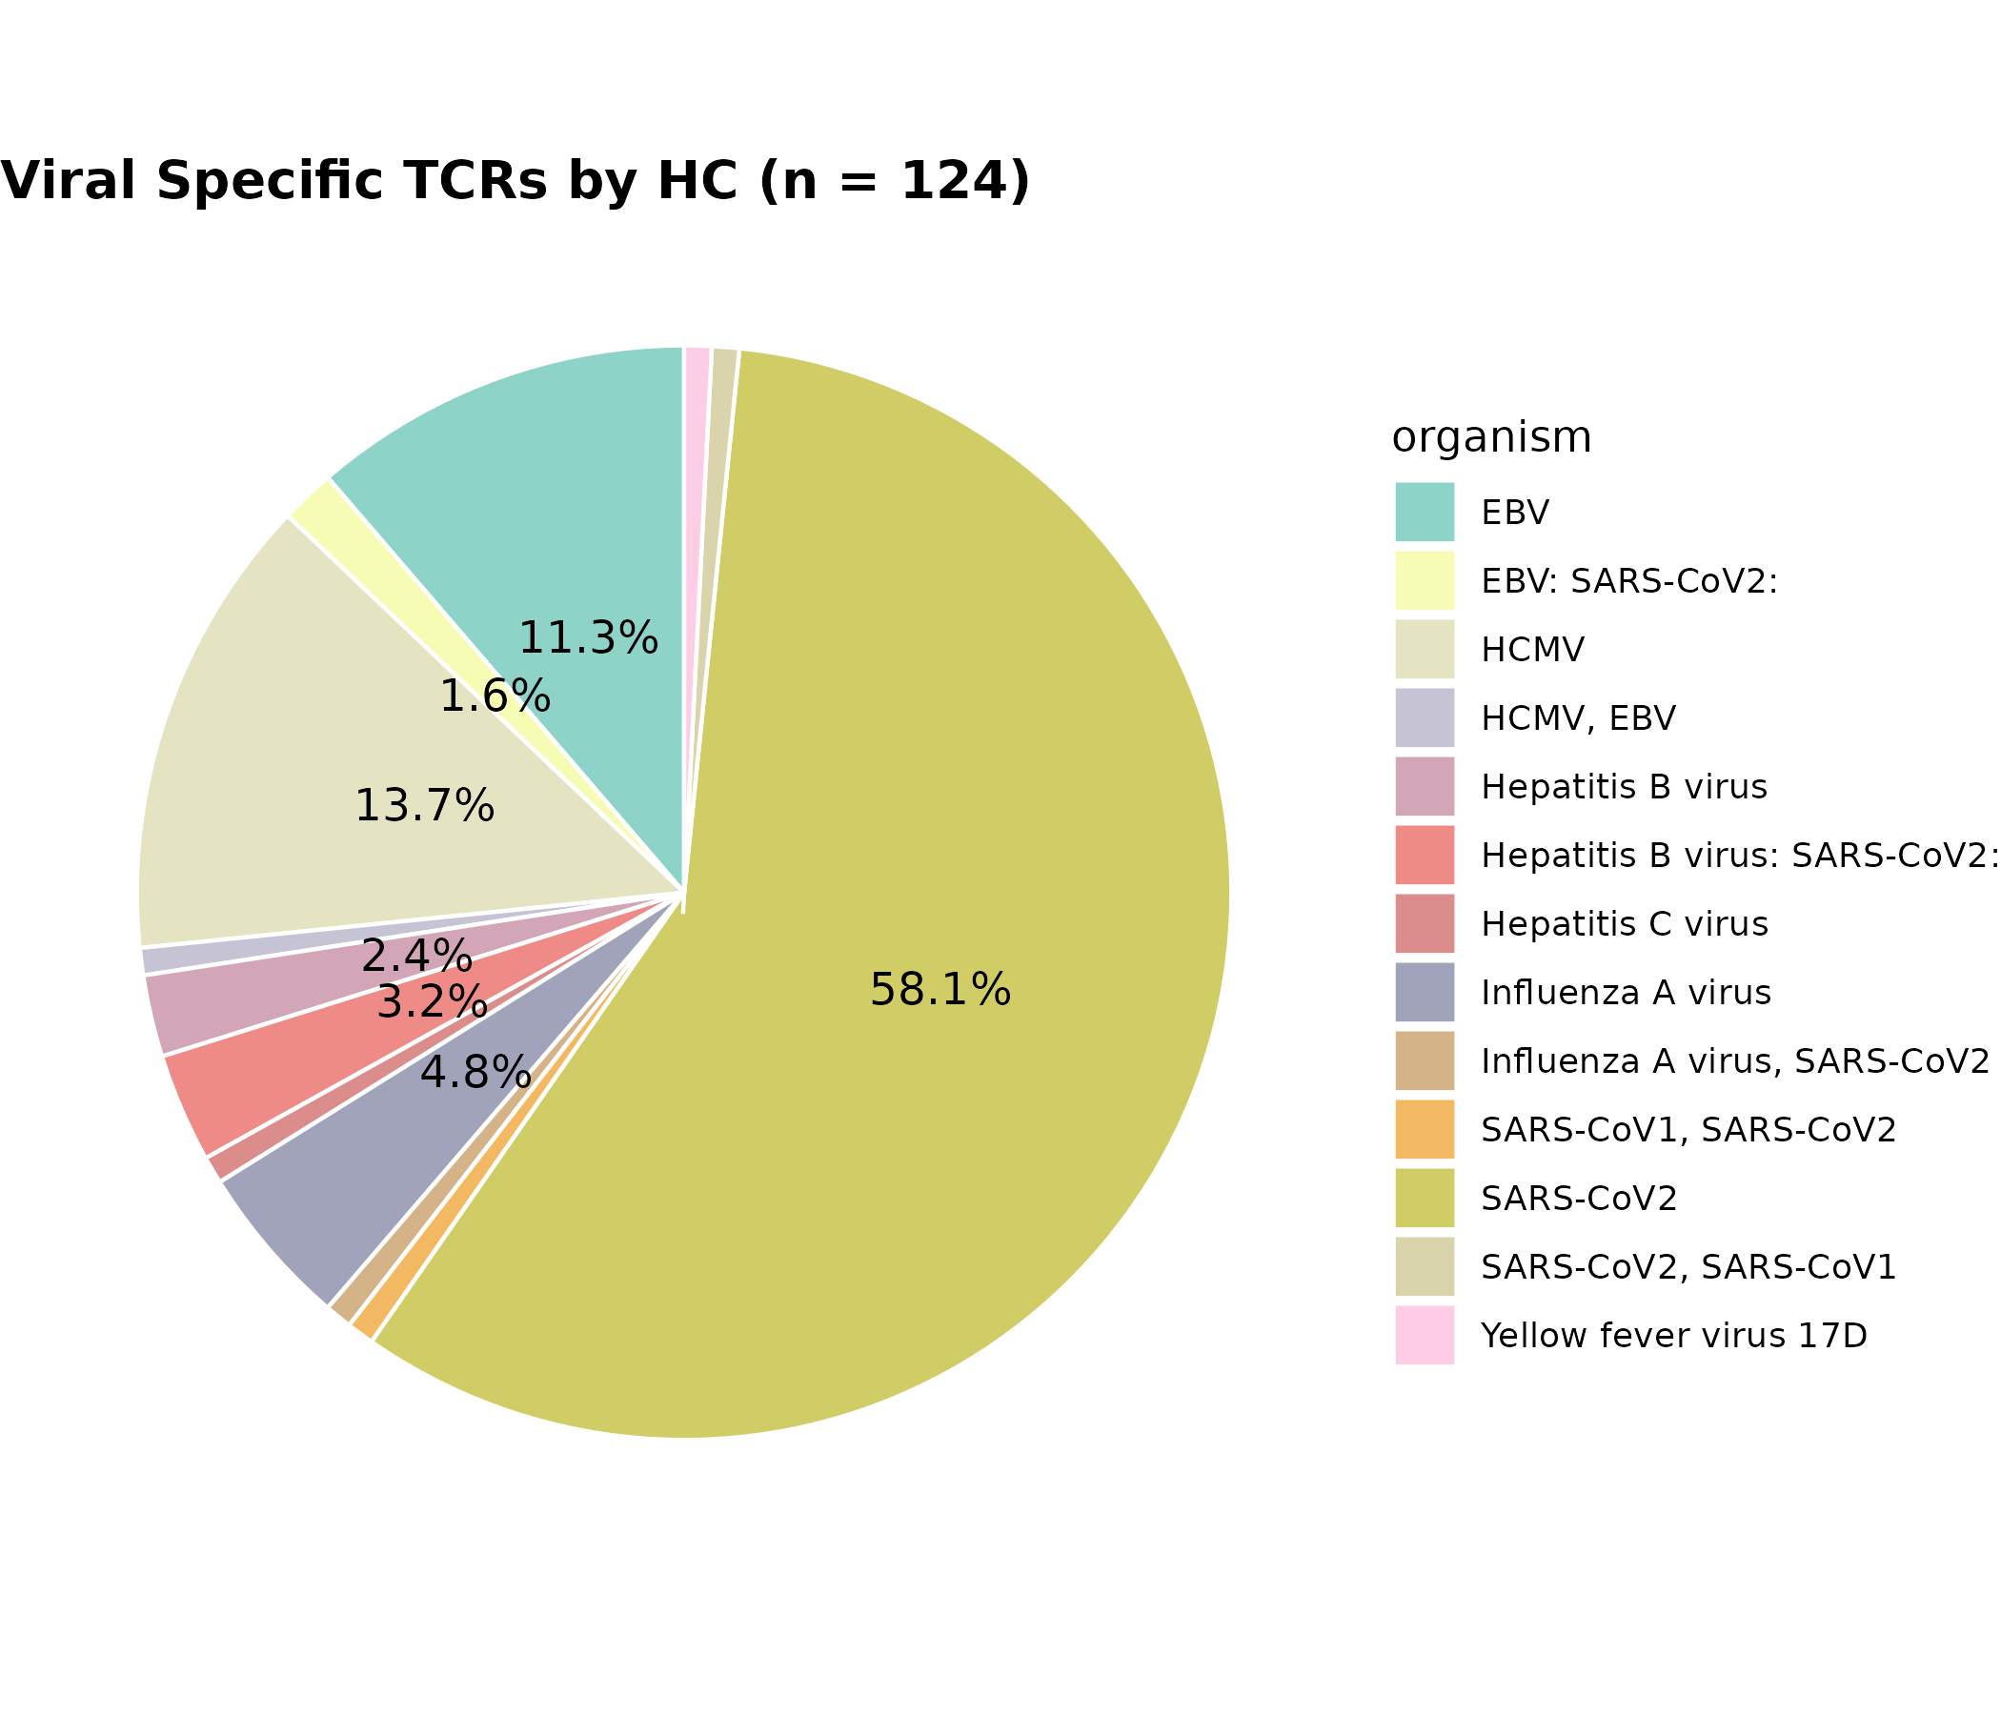
Figure 14. Distribution of Viral Antigen-Specific TCRs in the HC Group
This pie chart shows the distribution of viral antigen-specific T cell receptors (TCRs) among healthy control (HC) samples. Each slice reflects the relative proportion of TCRs recognizing specific viral antigens based on curated TCR metadata. SARS-CoV-2–reactive TCRs dominate the landscape, accounting for 58.1% of the total. This is followed by CMV (13.7%) and EBV (11.3%), suggesting previous or latent exposure. Smaller fractions include responses against Influenza A (4.8%), HHV-6B (3.2%), HIV-1 (2.4%), and Hepatitis C virus (1.6%). The remaining viral species—including Enterovirus B, HPV, HSV-2, and others—were each represented by ≤1.6% of the detected TCRs.
n = 124, this means there are 124 unique viral TCR entries (rows) among 280 from the samples
Results Summary (HC Group):
Among healthy controls, SARS-CoV-2–specific TCRs made up the majority of viral reactivity (58.1%). CMV and EBV followed with 13.7% and 11.3%, respectively. Additional TCRs were directed against Influenza A (4.8%), HHV-6B (3.2%), HIV-1 (2.4%), and Hepatitis C virus (1.6%). The remaining viruses each contributed ≤1.6%, suggesting a broad yet low-frequency background of viral antigen exposures in healthy individuals.

# TCRs specific to a particular viral organism

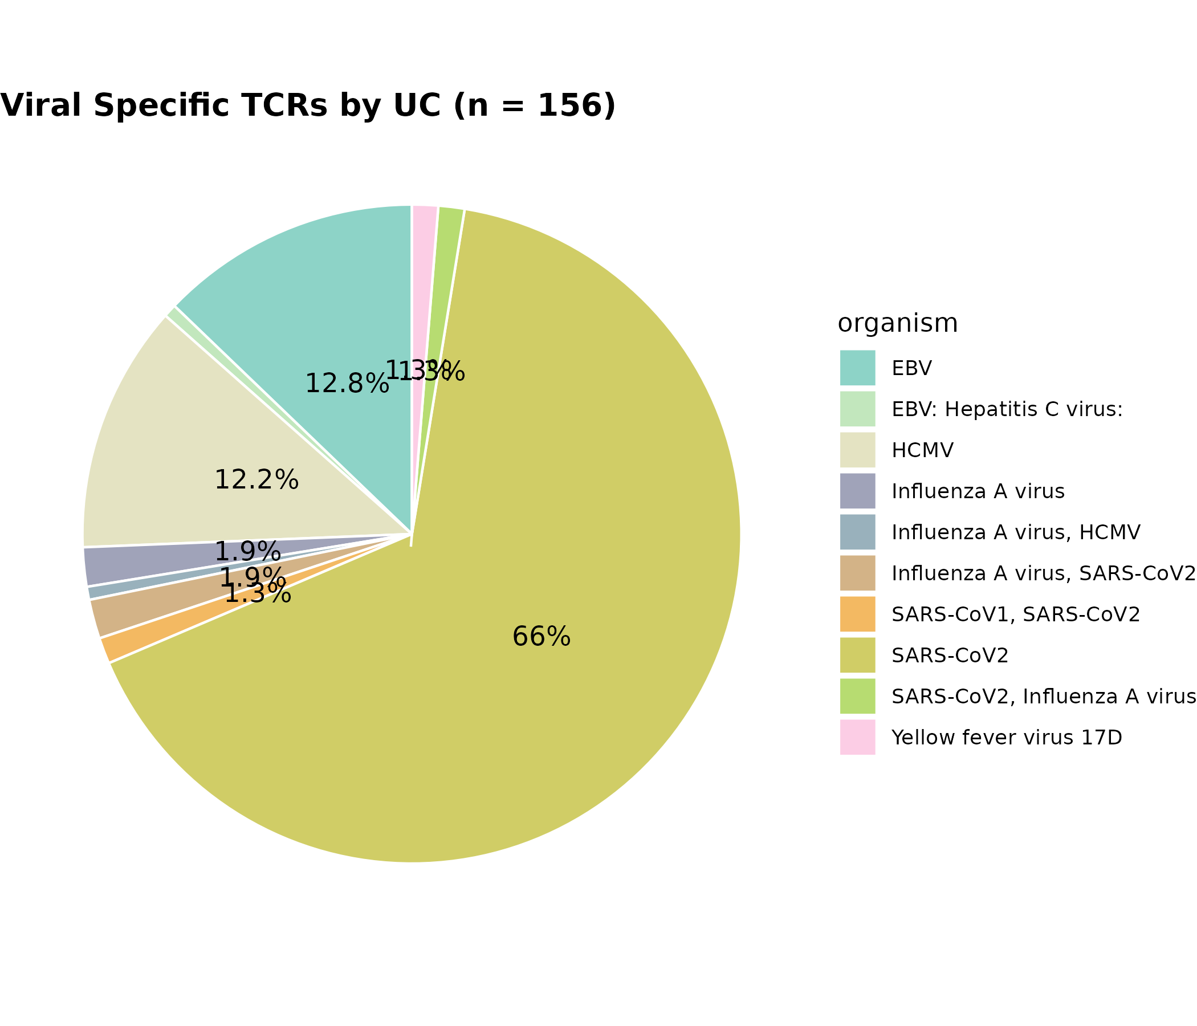

Figure 14. Distribution of Viral Antigen-Specific TCRs in the UC Group
This pie chart illustrates the distribution of viral antigen-specific T cell receptors (TCRs) in ulcerative colitis (UC) samples. Each segment represents the proportion of TCRs specific to a particular viral organism, as identified from curated TCR metadata. The dominant antigen-specific TCRs were directed against SARS-CoV-2 (66.0%), followed by Epstein–Barr virus (EBV; 12.8%) and human cytomegalovirus (HCMV; 12.2%). Smaller contributions were observed from Hepatitis C virus (1.9%), HHV-6B (1.3%), HIV-1 (1.3%), Enterovirus B (1.3%), and Parvovirus B19 (1.3%). The data reflect antigen diversity among UC samples, with SARS-CoV-2–reactive clones constituting the majority.
n = 156, this means 156 unique viral TCR entries from samples S24, S33, and S34 met the same criteria as above among 280.

Results Summary (UC Group):
In the UC cohort, SARS-CoV-2–specific TCRs comprised the largest fraction (66.0%) of viral reactivity. EBV and HCMV were also prevalent, accounting for 12.8% and 12.2% of the total, respectively. Viral TCRs targeting Hepatitis C virus, HHV-6B, HIV-1, Enterovirus B, and PVB19 each represented approximately 1.3–1.9%, suggesting a lower but diverse background of chronic or persistent viral exposures.

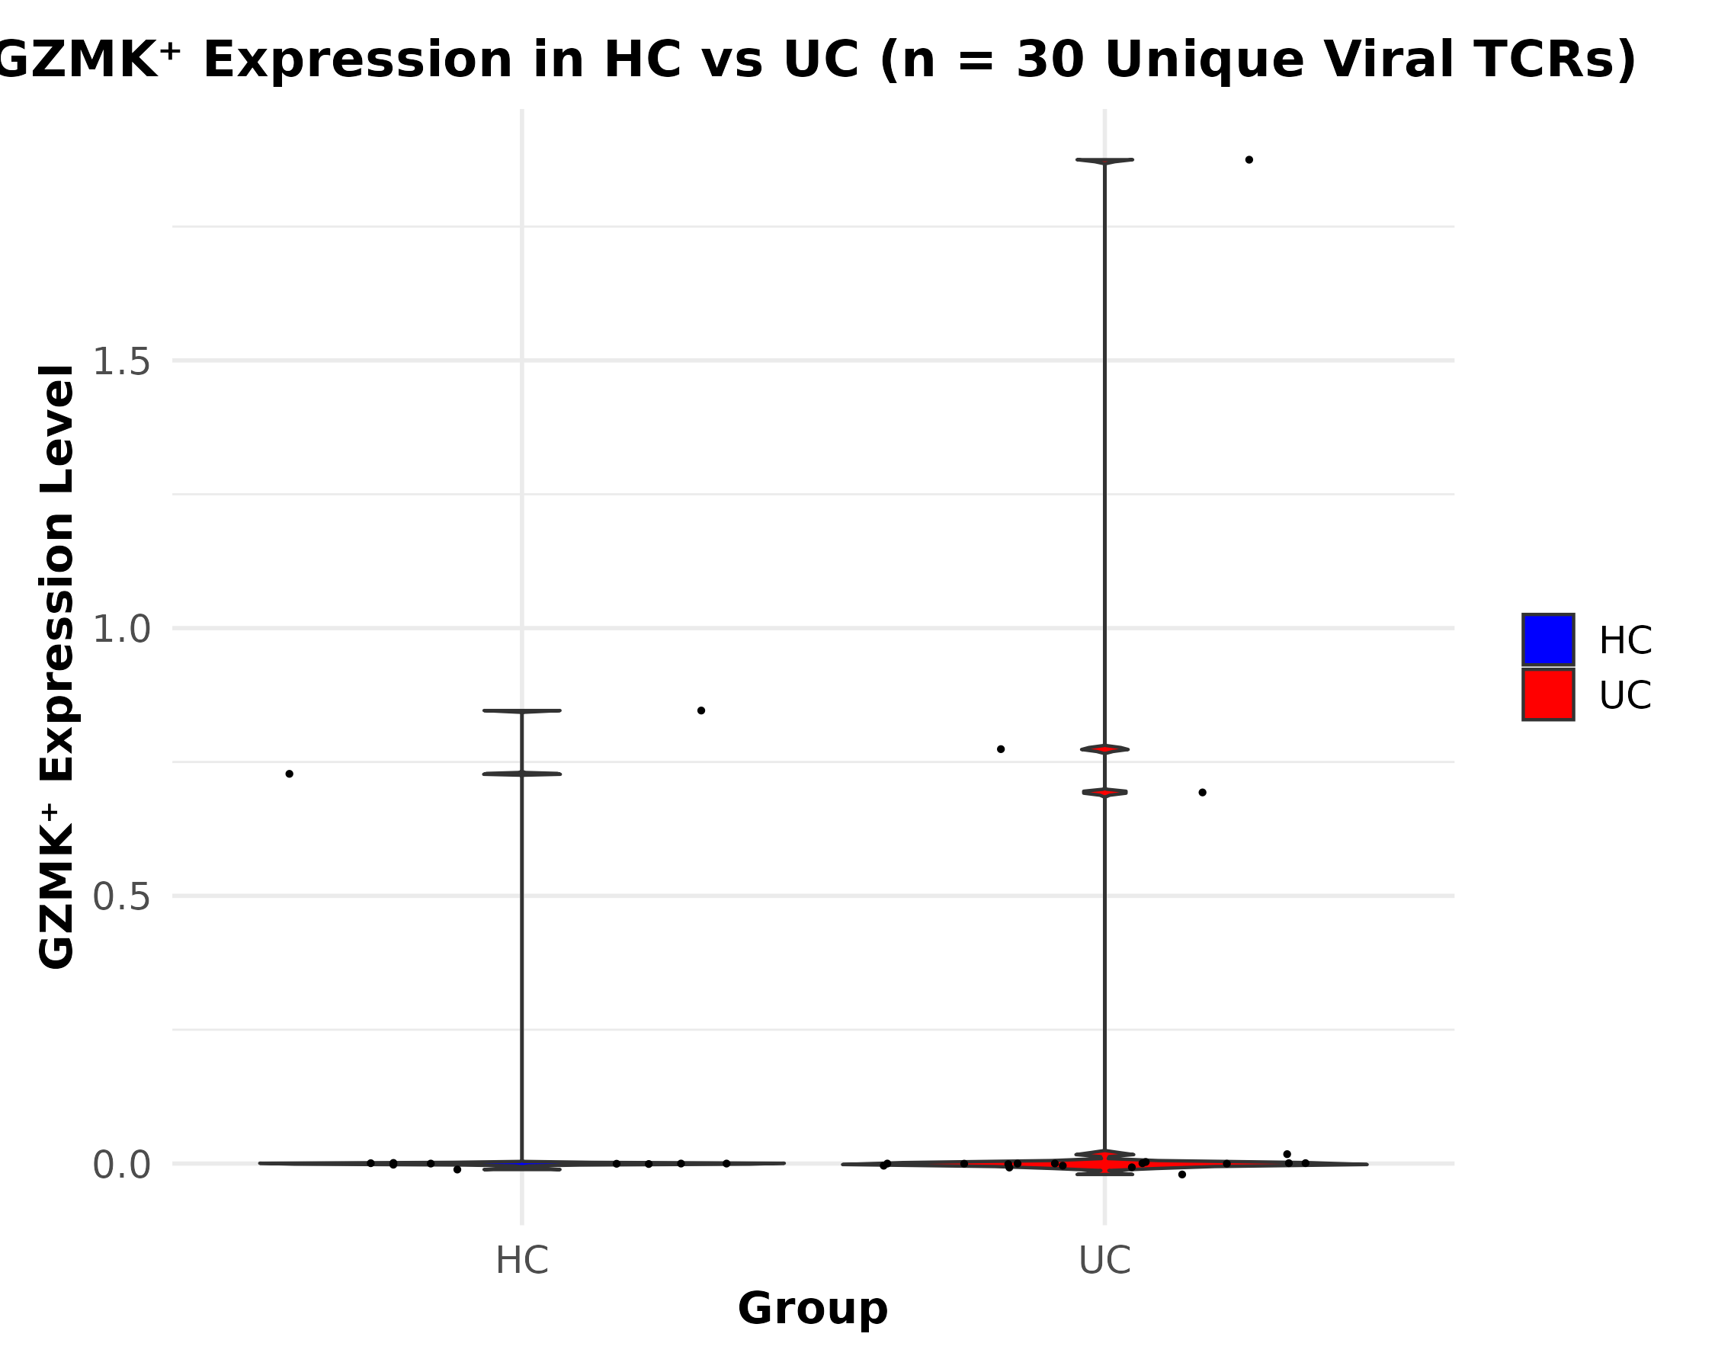

Figure 16. GZMK expression levels in viral TCR-positive T cells across healthy control (HC) and ulcerative colitis (UC) groups.
This violin plot illustrates the expression distribution of the cytotoxic effector gene GZMK in viral TCR-bearing T cells stratified by disease status. Each dot represents a single cell, grouped into HC (Healthy Control) and UC (Ulcerative Colitis) categories. The y-axis shows normalized expression levels of GZMK, and the x-axis separates cells by clinical group. The fill colors indicate group identity: salmon for HC and turquoise for UC.
Short Results Summary
A wider range and slightly higher upper-bound GZMK expression were observed in UC compared to HC. However, the majority of cells in both groups exhibited low expression, indicating that while GZMK may be elevated in a subset of UC cells, its expression is generally sparse.

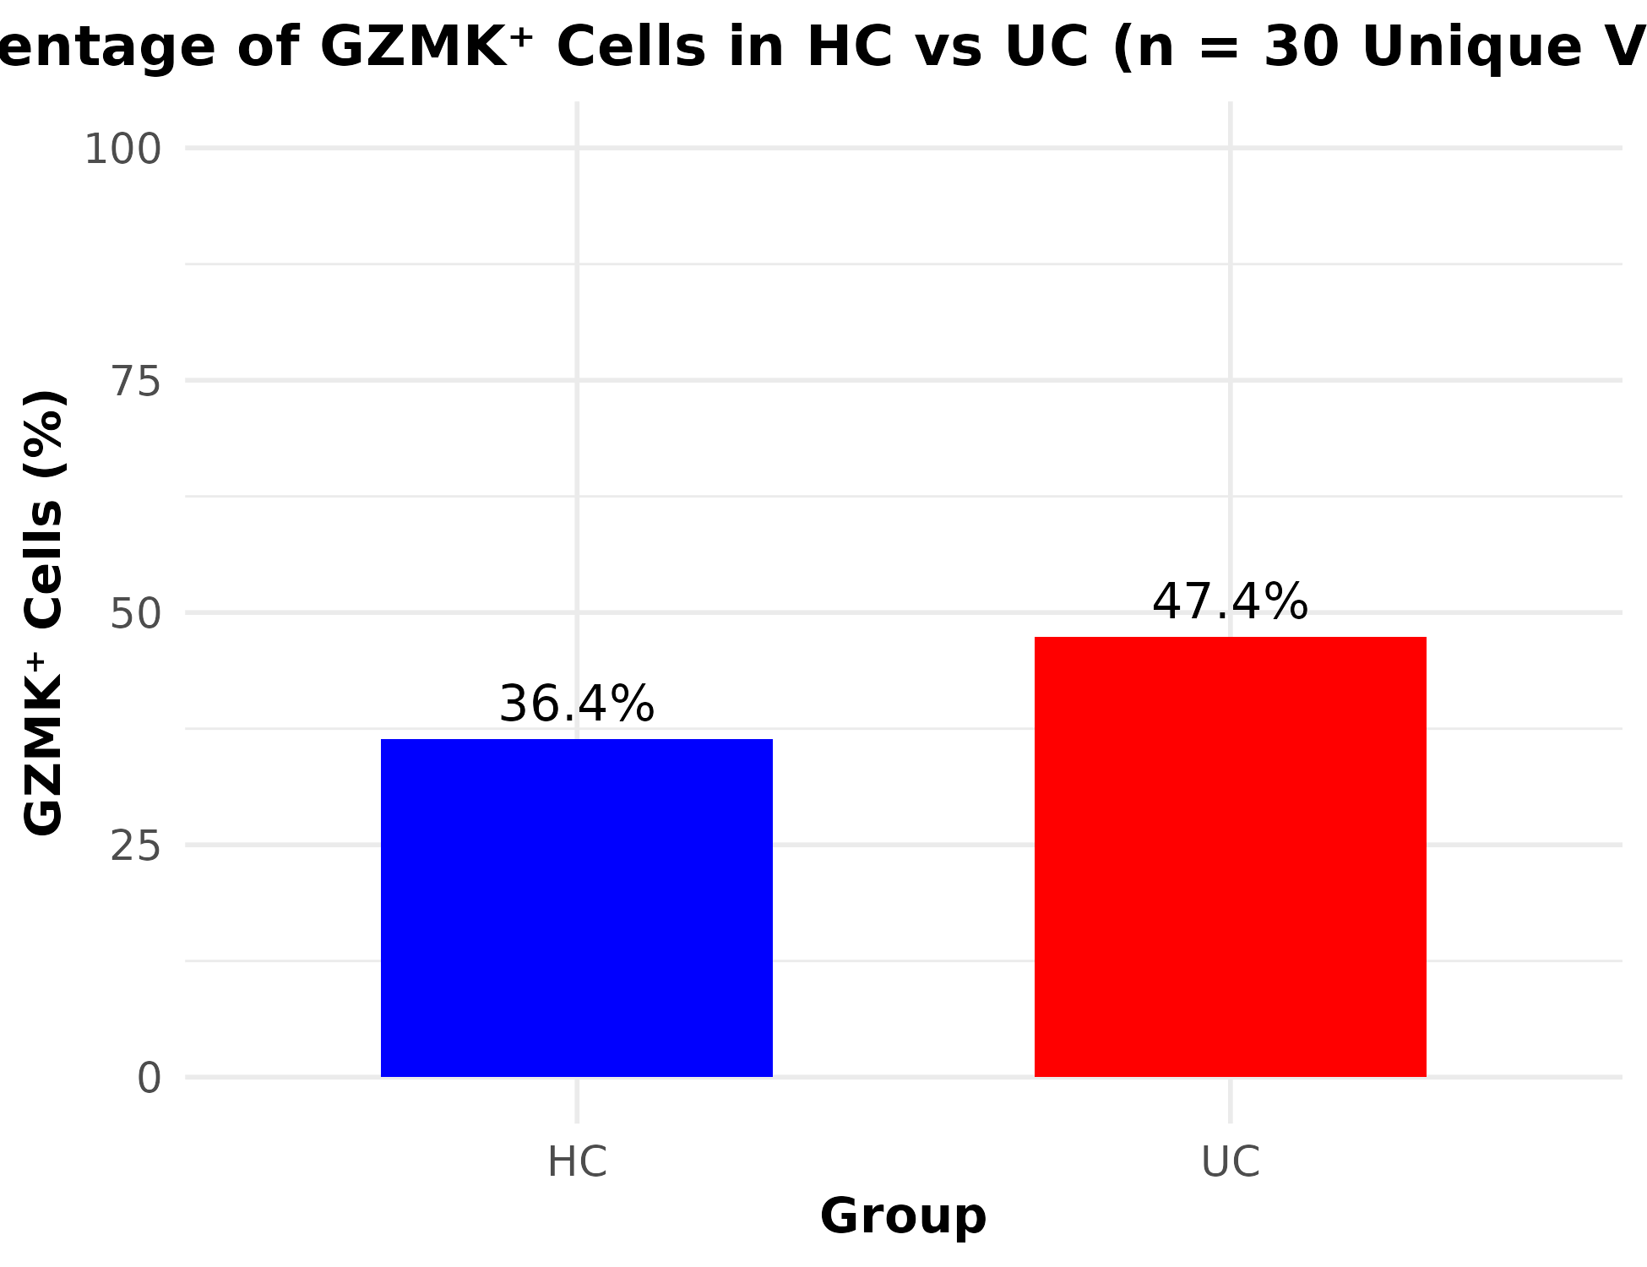
For GZMK > 0)
Figure 17. Proportion of GZMK-positive viral TCR-bearing T cells in HC and UC groups.
This bar plot shows the percentage of GZMK-positive cells, defined as those with expression values greater than zero, among viral TCR-labeled T cells in HC and UC groups. The x-axis represents the group classification, and the y-axis represents the percentage of cells expressing GZMK. Salmon bars correspond to HC, and turquoise bars to UC. Numerical labels above the bars indicate the exact percentages.
Results Summary (In-Figure Text or Caption):
Approximately 39% of HC cells and 47% of UC cells were GZMK-positive, indicating a modest increase in GZMK+ cell frequency in the UC group.

Table for Manuscript (GZMK+ Summary for HC vs UC)
Group | Total Cells | GZMK+ Cells | % GZMK+
HC | 11 | 4 | 36.4%
UC | 19 | 9 | 47.4%

Statistical Test Summary
Test | p-value | Interpretation
Wilcoxon Rank-Sum | 1.000 | No difference in GZMK expression levels
Fisher’s Exact Test | 0.708 | No significant difference in GZMK+ cell count

Suggested Result
In the Figure 16. (Comparison of GZMK Expression in Viral TCR-Positive T Cells Between HC and UC Groups)
This analysis compares the expression of the cytotoxic marker GZMK in T cells carrying viral antigen-specific TCRs from healthy control (HC) and ulcerative colitis (UC) groups. Among 30 uniquely matched viral TCR-labeled Seurat cells, 36.4% of HC cells and 47.4% of UC cells expressed GZMK. However, statistical testing revealed no significant difference in GZMK expression distribution (Wilcoxon p = 1.0) or in the proportion of GZMK+ cells (Fisher’s exact p = 0.71) between the groups.
"No significant difference" means that based on our statistical test results (p-values), there is not enough evidence to say that the two groups-HC (healthy control) and UC (ulcerative colitis), are truly different in terms of GZMK expression.

In our context:
- Wilcoxon p-value = 1.0 : There is no difference in the distribution of GZMK expression values between HC and UC.
- Fisher’s exact p-value = 0.708 : The proportion of GZMK+ cells is not statistically different between HC and UC.

Why this happens:
This might be due to:
- Small sample size (only 30 matched cells),
- Biological variability,
- Biological variability,
- Or the actual difference being very small.

Does this mean our finding is wrong?
No, it doesn't mean our data is incorrect. It just means that statistically, the observed difference (e.g., 36.4% vs. 47.4%) could be due to random chance in a small dataset.

In results
Although the UC group exhibited a higher percentage of GZMK+ viral TCR-bearing cells (47.4%) compared to the HC group (36.4%), this difference was not statistically significant (Fisher’s exact p = 0.71; Wilcoxon p = 1.0), suggesting comparable levels of GZMK-associated cytotoxic activity between the two groups in this dataset.
Statistical analysis approaches:
Two complementary statistical tests here to analyze GZMK expression differences between HC and UC groups:

1. Wilcoxon Rank-Sum Test (Mann-Whitney U test)
wilcox_result <- wilcox.test(GZMK ~ Group30_exact, data = expr_data)

Purpose: To compare the distribution of GZMK expression levels between HC and UC without assuming normality.

Type of Data:
- Continuous or ordinal data (e.g., GZMK expression values)
- Two independent groups (HC and UC)

Why it’s appropriate:
- GZMK expression levels are likely not normally distributed, especially in a small sample (n = 30).
- The Wilcoxon test is non-parametric and robust to outliers/ties, so it's a safe choice here.

2. Fisher’s Exact Test
fisher_table <- table(expr_data$Group30_exact, expr_data$GZMK_Positive)
fisher_result <- fisher.test(fisher_table)

Purpose: To test whether the proportion of GZMK+ cells (GZMK > 0) differs between HC and UC groups.

Type of Data:
- Categorical data (GZMK+ vs GZMK−)
- 2×2 contingency table: HC/UC vs Positive/Negative

Why it’s appropriate:
- Sample size is small (e.g., only 11 HC and 19 UC cells), so Fisher’s Exact Test is better than Chi-squared.
- It tests for statistical association between group and marker positivity.

Summary in table:
Test | Input | Question Answered | Justification
Wilcoxon test | GZMK expression per cell | Do expression levels of GZMK differ between HC and UC? | Robust non-parametric test for small, skewed data
Fisher's test | GZMK+ status per cell | Are HC and UC equally likely to have GZMK+ viral TCR cells? | Best for small counts in categorical contingency tables

Output/ results Summary:
To assess GZMK expression differences between healthy controls (HC) and ulcerative colitis (UC) groups for unique viral TCRs (n=30), we performed both a Wilcoxon rank-sum test on GZMK expression levels and a Fisher’s exact test on GZMK-positive cell frequencies. These tests provide complementary insights-one evaluating distributional shifts in expression intensity and the other testing enrichment of cytotoxic marker expression. Neither test revealed statistically significant differences (Wilcoxon p = 1.00; Fisher’s p = 0.708), suggesting no strong group-level GZMK activation bias within this small subset (n = 30).

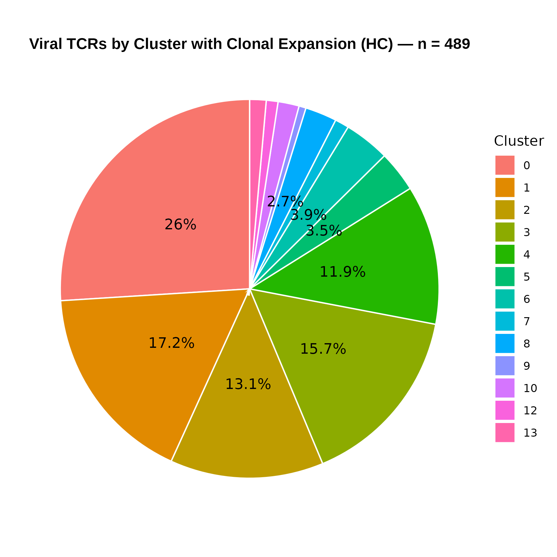

Figure 18. Distribution of Viral TCR Cells by Cluster in HC Samples
Pie chart representing the relative distribution of viral TCR-labeled Seurat cells, including clonal expansion, across clusters 0 to 13 in the Healthy Control (HC) group. Each slice corresponds to a specific Seurat cluster. Percentage values represent the proportion of total viral TCR cells within each cluster. Colors are uniquely assigned to clusters using RColorBrewer "Set3" palette, facilitating consistent interpretation. All viral TCR-labeled cells are included, accounting for expanded clones. Legend (right): Each color represents one Seurat cluster (0-13). Percentage labels indicate the relative contribution of each cluster to the total viral TCR cell pool in HC samples

Short Result Summary
The figure illustrates a broad distribution of viral TCR cells across clusters in HC samples:
Cluster 0 accounts for the largest share (26%), suggesting a major contribution of this cluster to viral-specific responses. Clusters 1-4 also show substantial representation (13-17% each), while clusters 8-13 contribute minimally. The results highlight that viral TCR activity in healthy individuals is dispersed across diverse cellular states, though certain clusters dominate

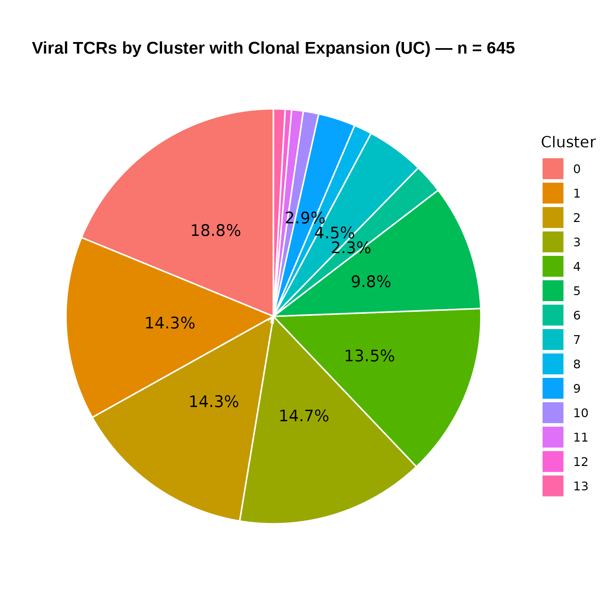

Figure 19. Distribution of Viral TCR Cells by Cluster in UC Samples
Pie chart showing the relative proportion of viral TCR-labeled Seurat cells, including clonal expansion, across clusters 0 to 13 for the Ulcerative Colitis (UC) group. Each slice represents a Seurat cluster (013). Percentage labels on each slice indicate the proportion of total viral TCR cells in that cluster. Colors are distinct for each cluster, using the RColorBrewer "Set3" palette for clarity. Data includes clonal expansion, so the counts reflect all matched cells, not just unique TCRs. Legend: Cluster ID represented by distinct color; consistent coloring across figures is recommended.
Short Result Summary
The figure demonstrates that viral TCR cells in UC samples are not evenly distributed across clusters. Cluster 0 (18.8%) contains the highest proportion of viral TCRs, suggesting a possible hotspot for antigen-specific expansion. Clusters 1 to 4 also show significant representation (13% to 15% each), while others like clusters 9-13 contribute minimally (<5% each). The diversity across clusters reflects heterogeneous immune responses in UC and potential involvement of specific cellular phenotypes.

# Clonally expanded (barcodes that appear more than once, n > 1)
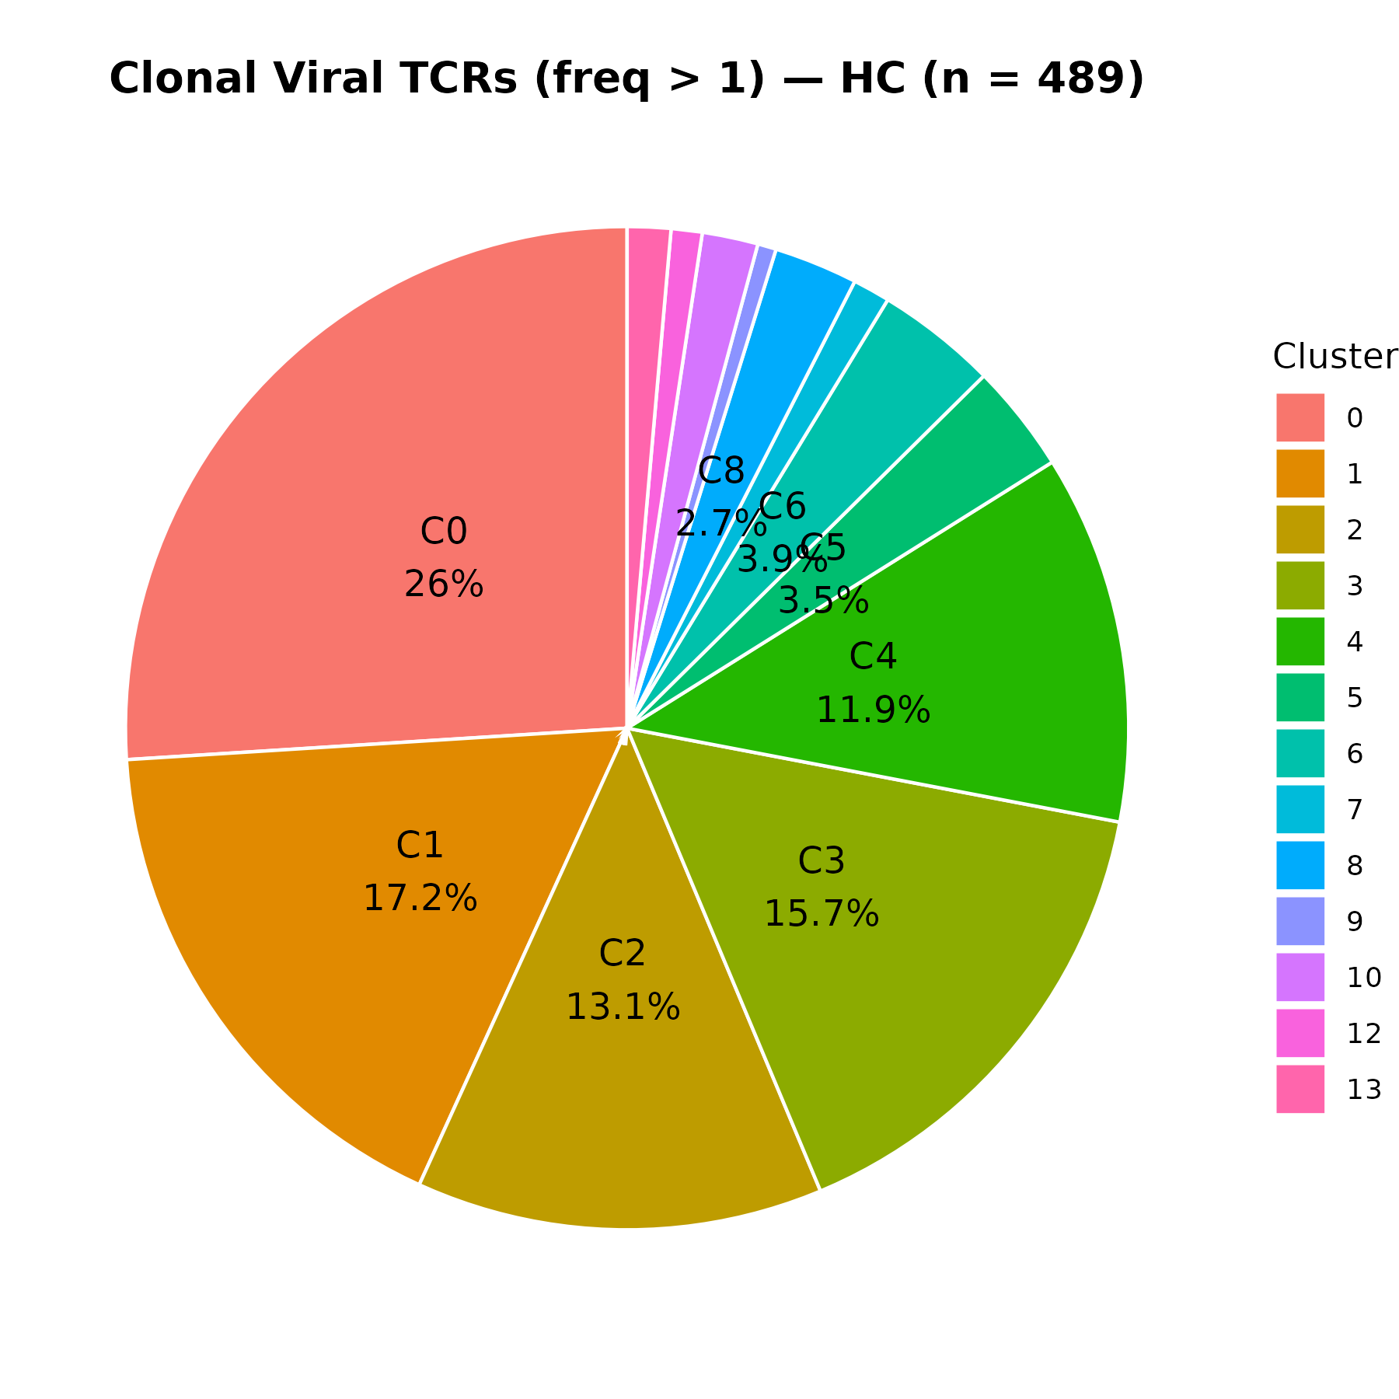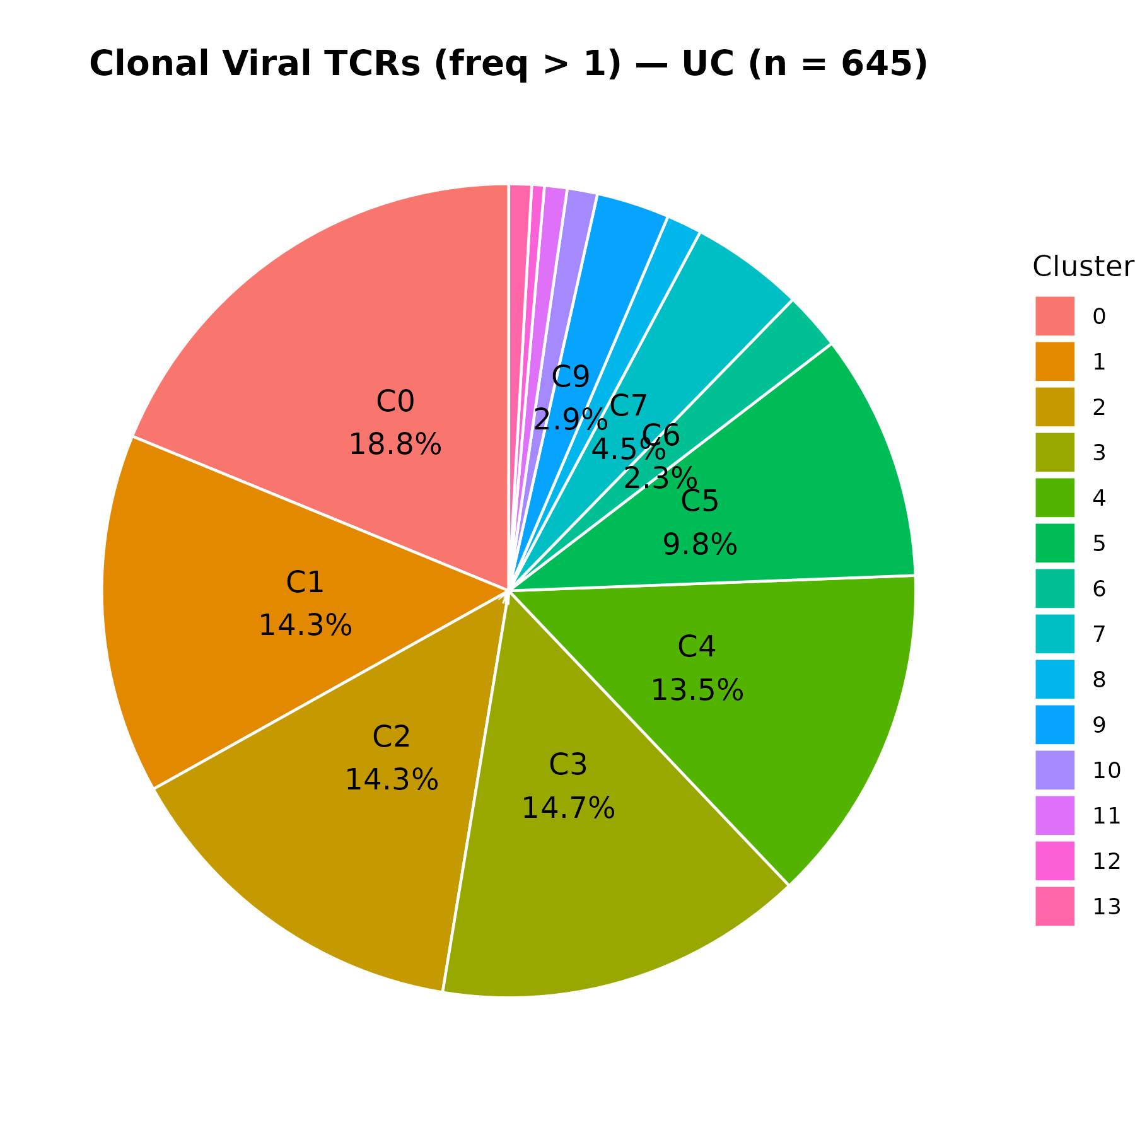
These two figures are identical for Figure 18 and Figure 19 respectively.

# Highly expanded (barcodes that appear more than four times, n > 4)
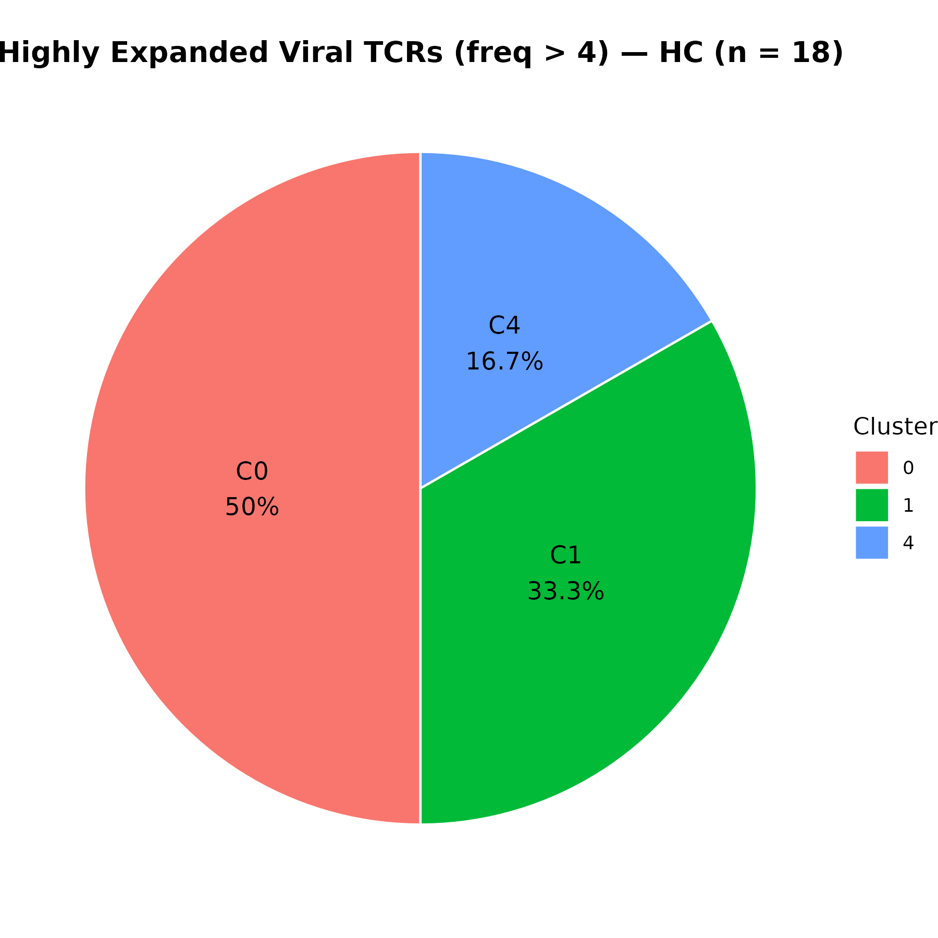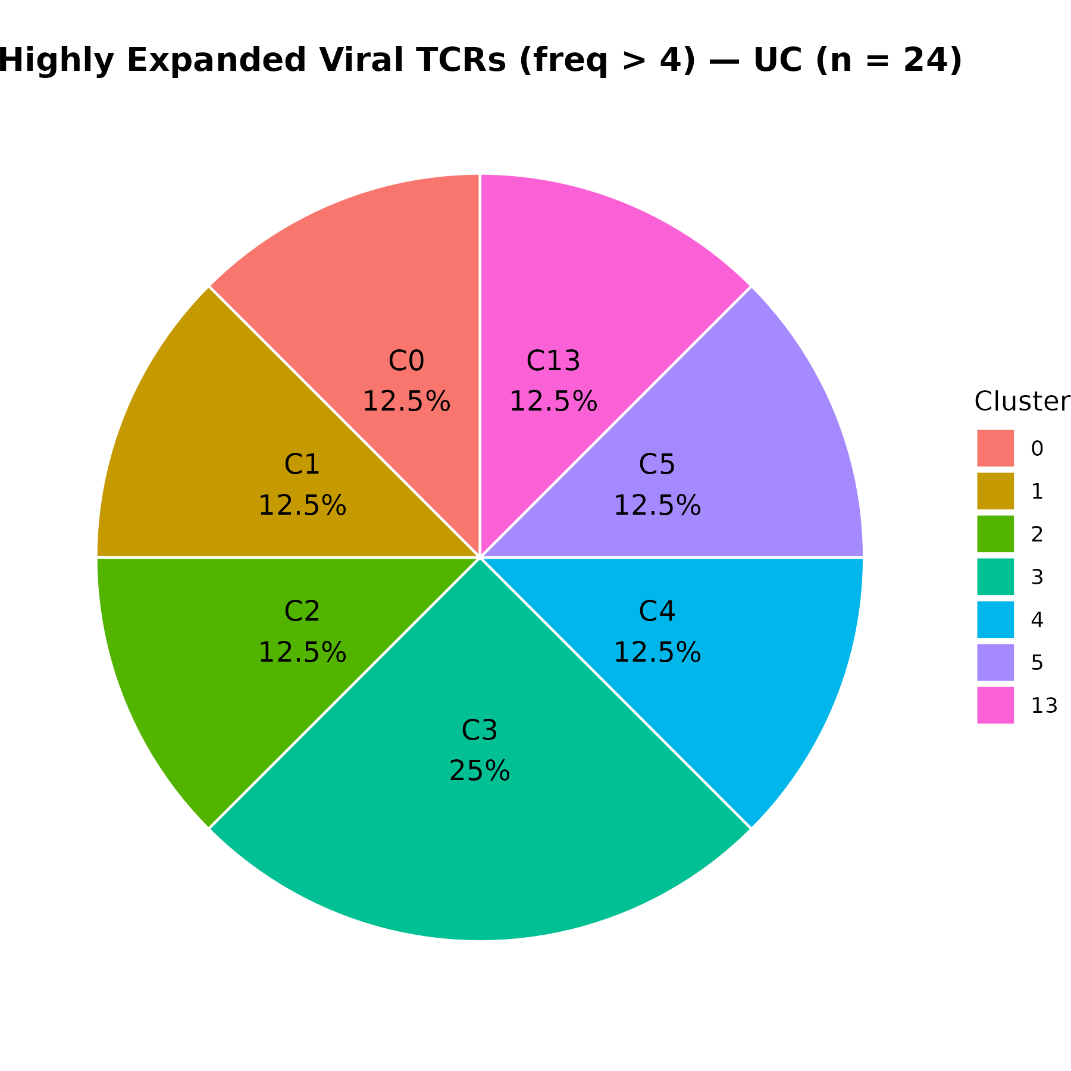

Figure 20: Distribution of clonally expanded (freq > 4) GZMK⁺ viral TCR cells across clusters in (A) Healthy Controls (HC) and (B) Ulcerative Colitis (UC).
Panel A (left): HC group
Pie chart displays the proportion of GZMK⁺ viral TCR cells that are clonally expanded (frequency > 4) across the 14 Seurat clusters.
Clusters C0, C1, and C4 account for the majority of such cells in HC.
    - C0: 50%
    - C1: 33.3%
    - C4: 16.7%
Panel B (right): UC group
More even distribution across multiple clusters, with each of the eight clusters containing 12.5% or 25% of the clonally expanded GZMK⁺ viral TCR cells.
    - C3: 25%
    - C0, C1, C2, C4, C5, C13: each ~12.5%

Results Summary
In GZMK⁺ cells with clonal expansion frequency > 4:
- Healthy Controls (HC) show dominance in a few clusters, particularly Cluster 0 (50%) and Cluster 1 (33.3%), indicating potential enrichment of clonally expanded antiviral cells in specific immune niches.
- Ulcerative Colitis (UC) samples reveal a more dispersed cluster distribution, with cells present across eight clusters, suggesting a broader or less focused activation profile.

# Information about GZMK in Viral TCRs comes from HC with donors (S21, S22, S23), and UC with donors (S24, S33, S34).
- Total clonal viral TCR cells = 1134 in
- Only 66 of those cells are GZMK positive (GZMK > 0).
- Only 66 of those cells are GZMK positive (GZMK > 1)
- Only 66 of those cells are GZMK positive (GZMK > 2)
- Only 3 of those cells are GZMK positive (GZMK > 4).
- This suggests GZMK expression is very rare in clonally expanded viral TCRs.
- Also, GZMK+ cells are highly enriched among highly expanded clones (since all 66 passed the freq > 2 threshold).

# Violin: How strongly is GZMK expressed?

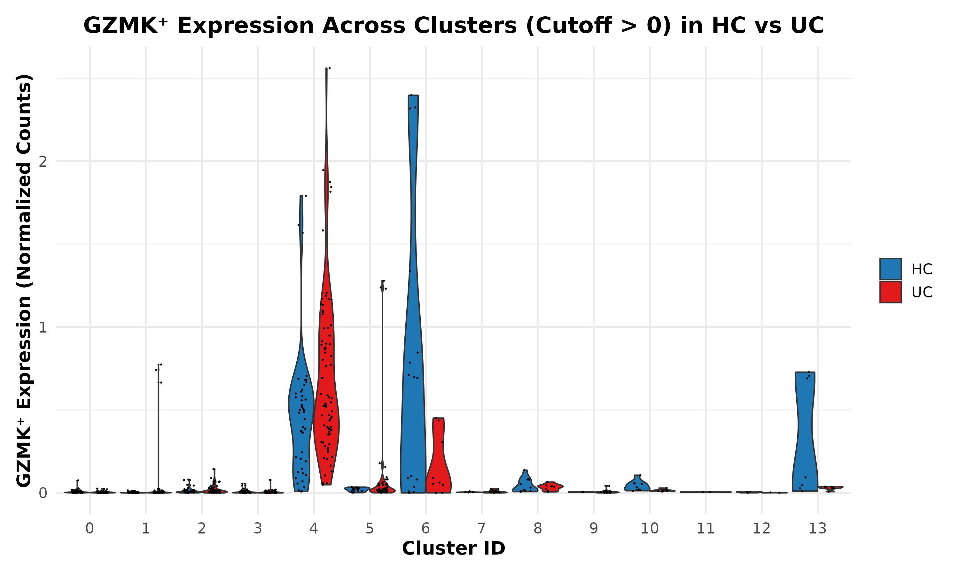
Figure 21. GZMK⁺ Viral TCR Expression Across Clusters in Healthy Controls (HC) and Ulcerative Colitis (UC) Patients
Violin plot showing the normalized expression of GZMK (cutoff > 0) across 14 Seurat clusters (0-013) for cells labeled as viral TCR-positive in either HC (blue) or UC (red) samples. Each point represents a GZMK⁺ cell. Cluster 4 and cluster 6 show strong enrichment of GZMK expression, particularly in the HC group. This visualization emphasizes group-wise differences in GZMK⁺ cell distribution across functional cell states.

Short Summary of Results
GZMK⁺ expression (cutoff > 0) is primarily concentrated in clusters 4 and 6. HC samples show broader and higher GZMK expression in these clusters, especially cluster 6. UC samples show moderate GZMK expression, particularly in cluster 4. Few to no GZMK⁺ cells were detected in other clusters, indicating cell-type specificity of GZMK expression within the viral TCR+ subset.
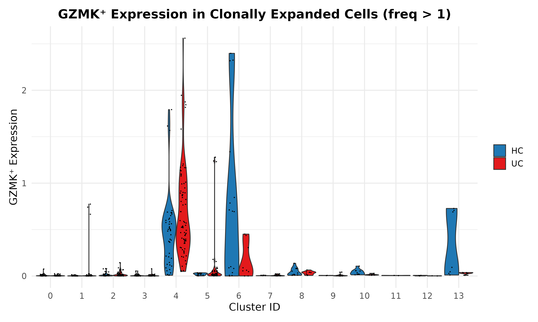
# This Figure is identical of Figure 21

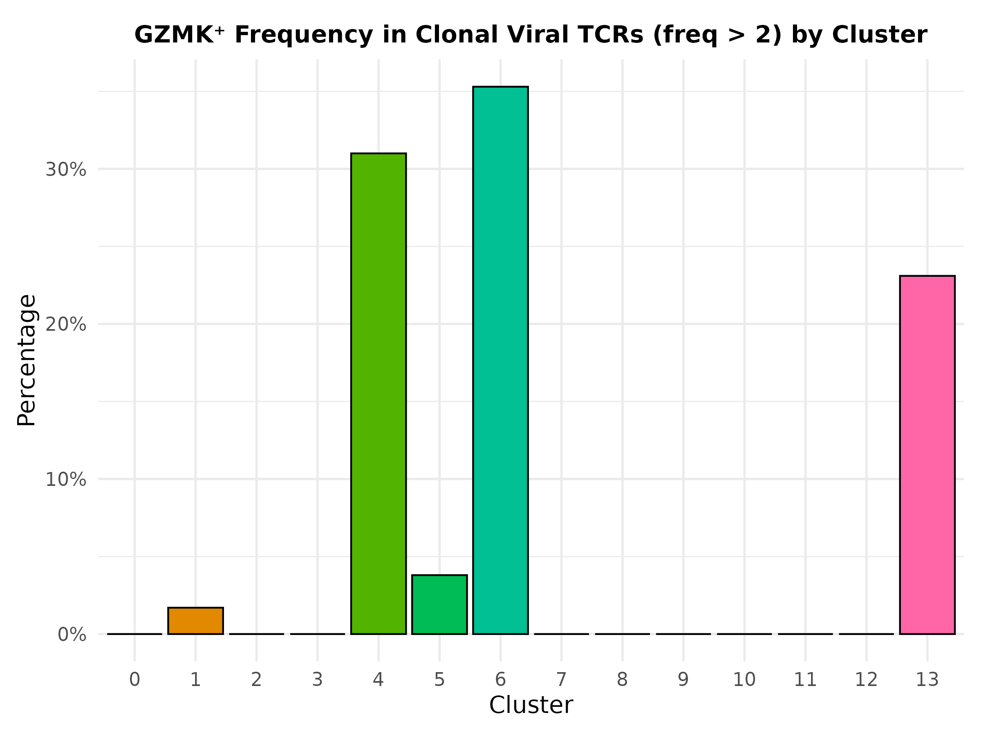

Figure 24A. Distribution of GZMK⁺ Clonal Viral TCRs (freq > 2) by Cluster
Bar plot showing the percentage of GZMK⁺ clonal viral TCR cells (frequency > 2) across the 14 transcriptional clusters (Cluster 0–13) in the combined Seurat object. Each bar represents the proportion (%) of cells expressing GZMK per cluster, relative to all clonal GZMK⁺ viral cells. Cluster identities are shown on the X-axis, and percentage on the Y-axis. X-axis: Seurat Cluster (0 to 13). Y-axis: Percentage of GZMK⁺ clonal viral cells. Bar Fill: Unique color per cluster. Interpretation: Clusters 4, 6, and 13 show enriched representation.

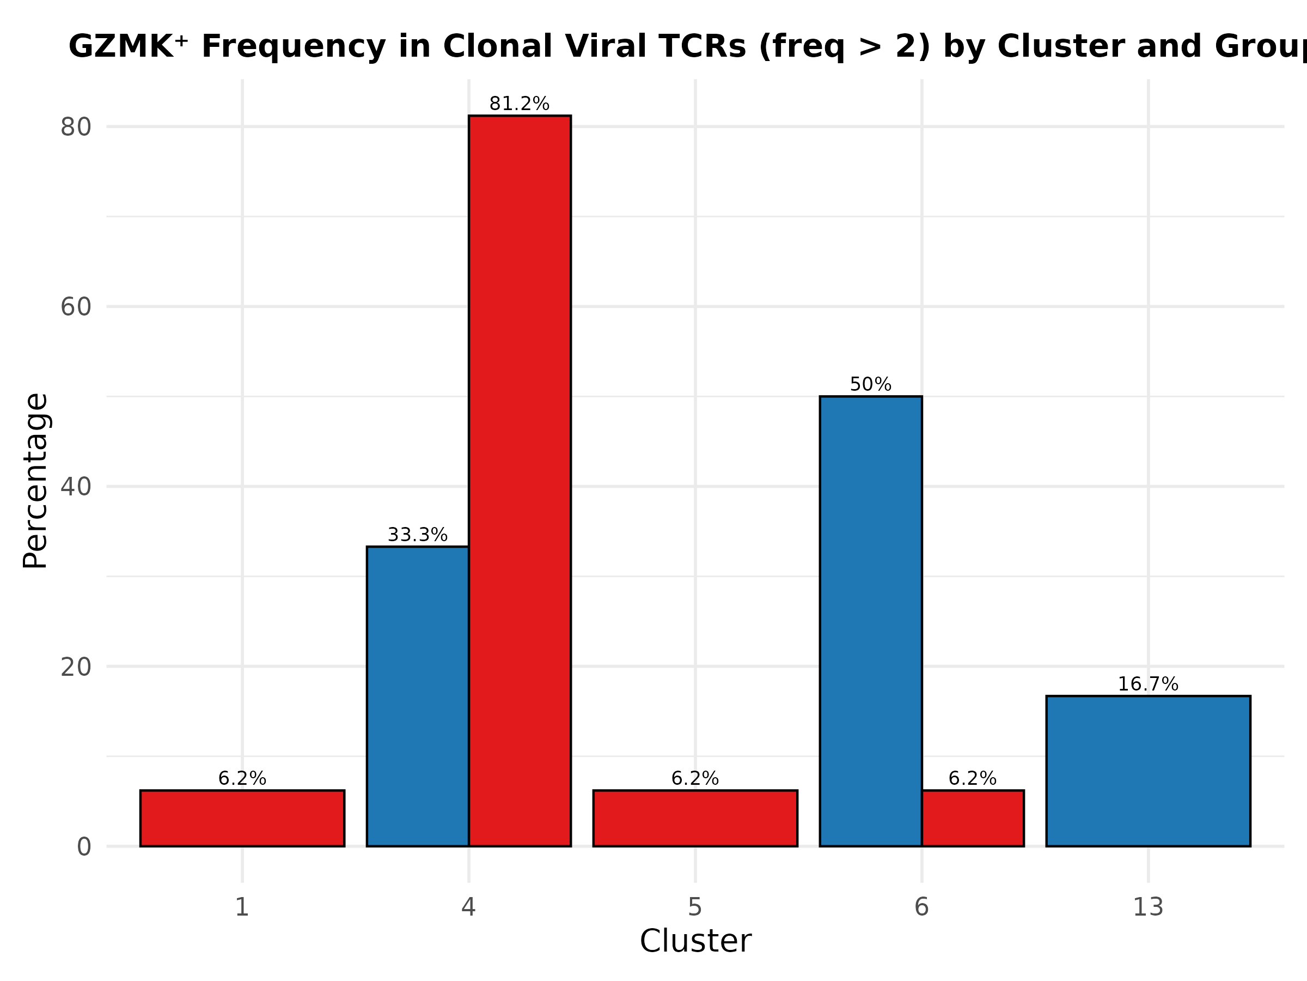

Figure 24B. Distribution of GZMK⁺ Clonal Viral TCRs (freq > 2) in HC and UC by Cluster
Bar plot displaying the contribution of GZMK⁺ clonal viral TCR cells (freq > 2) across transcriptional clusters, stratified by Group (Healthy Controls [HC] and Ulcerative Colitis [UC]). X-axis: Cluster ID (only clusters with GZMK⁺ cells are shown: 1, 4, 5, 6, 13). Y-axis: Cell count (raw number of GZMK⁺ clonal viral TCR cells). Red = UC. Blue = HC. Interpretation: Cluster 4 has a major UC-biased expansion; Cluster 6 is HC-biased.
Short Summary
Figure 24A illustrates the distribution of GZMK⁺ clonal viral TCR cells (frequency > 2) across transcriptional clusters. The majority of these cells are enriched in clusters 4 (31%), 6 (35%), and 13 (23%), suggesting phenotypic preference for GZMK expression in specific T cell subtypes.
Figure 24B In Healthy Controls (HC), GZMK⁺ clonal viral cells are predominantly found in clusters 6 and 13, while in Ulcerative Colitis (UC) patients, cluster 4 shows strong enrichment. This suggests divergent transcriptional activation or subset distribution of GZMK⁺ viral-specific T cells between HC and UC groups.

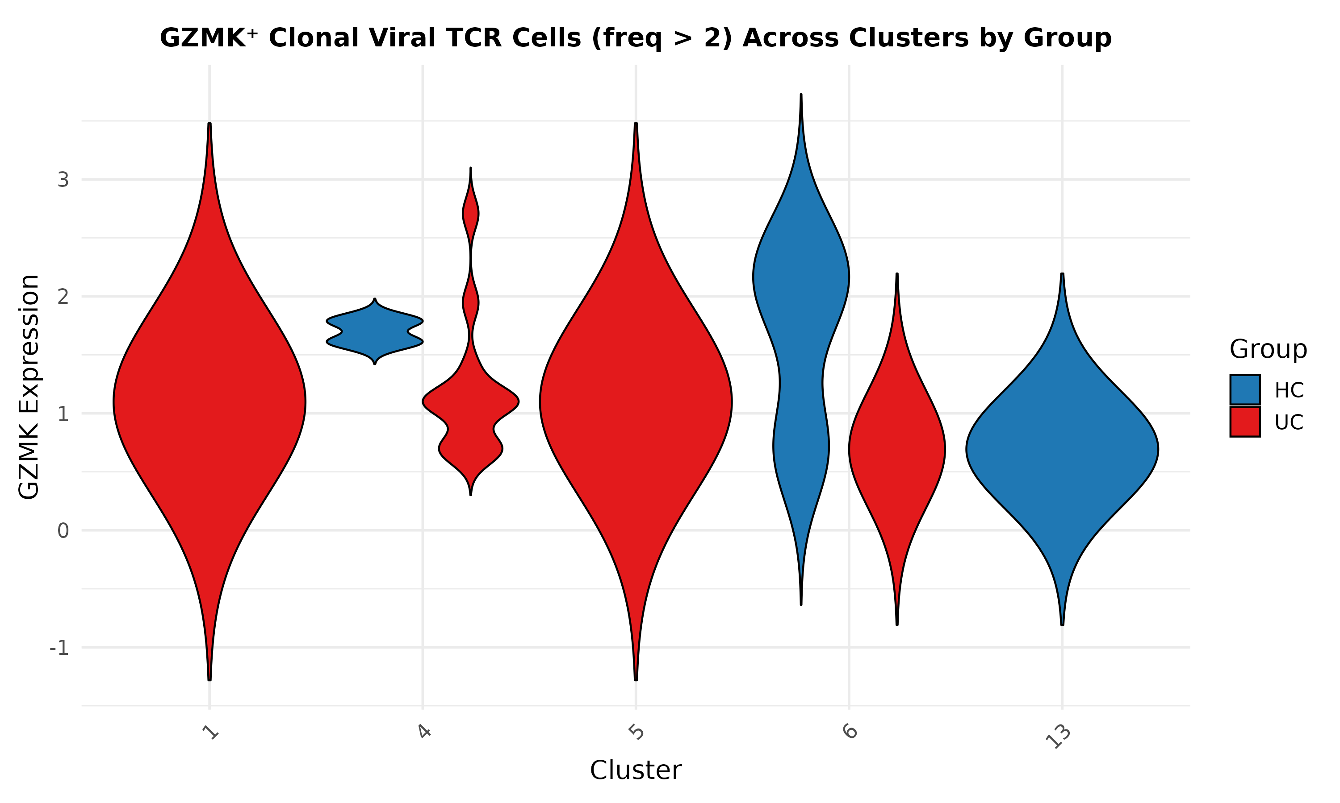

Figure 24C. Violin plot of GZMK⁺ clonal viral TCR cells (freq > 2) across clusters, stratified by group (HC vs UC). X-axis: Seurat clusters (0-13). Y-axis: Normalized GZMK expression (SCT layer). Blue = Healthy Controls (HC). Red = Ulcerative Colitis (UC). Plot features: Width represents the density of GZMK⁺ cells within each cluster; clusters with no data are absent.

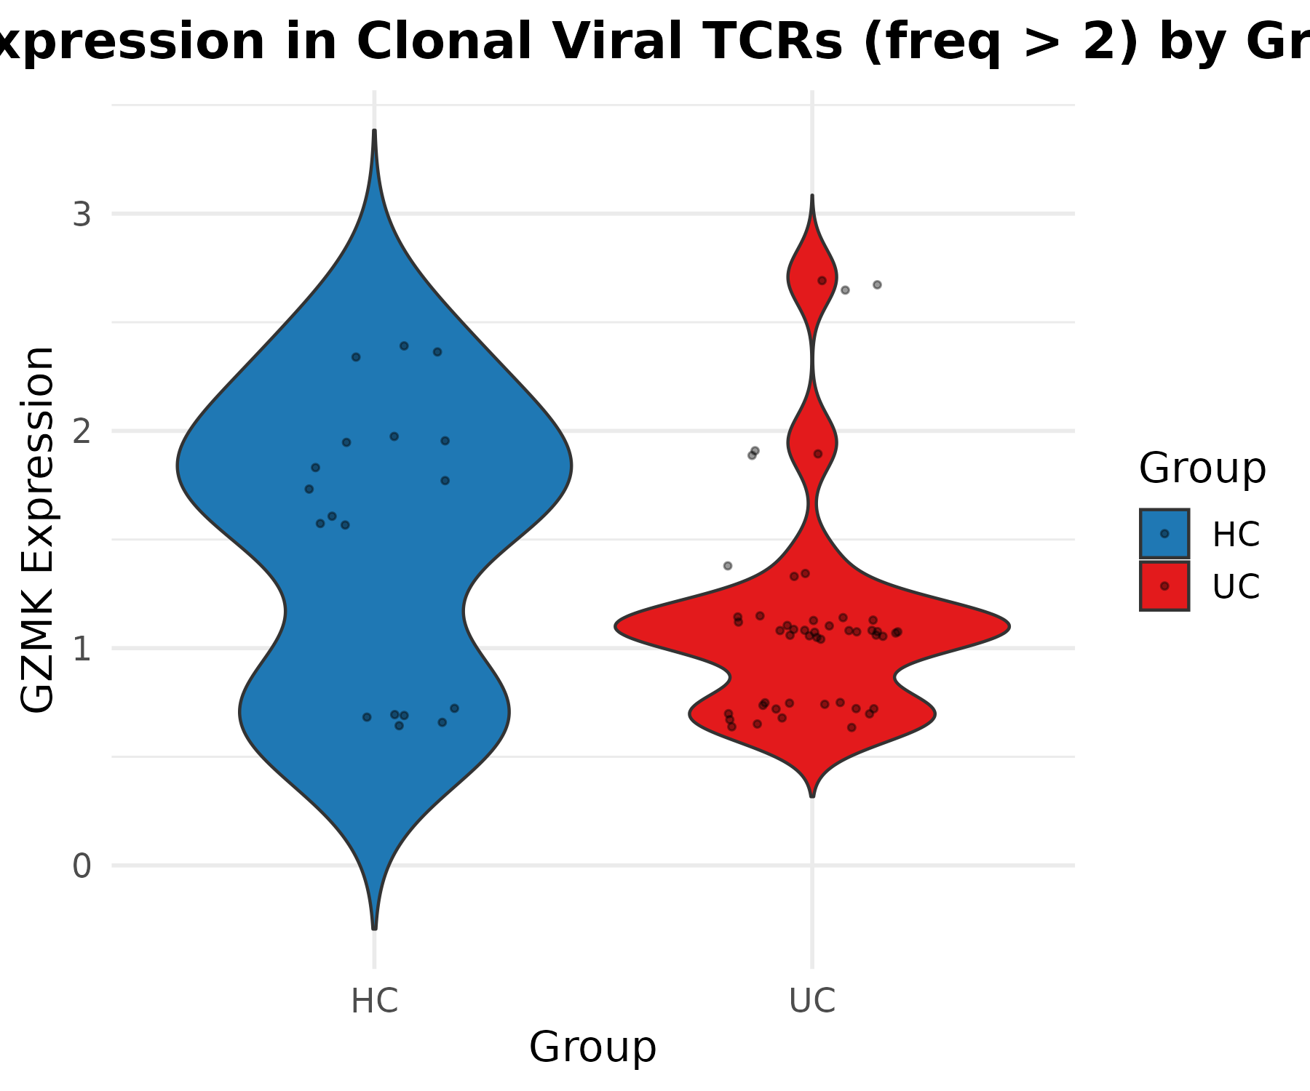

Figure 24D. Violin plot comparing GZMK expression in clonal viral TCR cells (freq > 2) between HC and UC groups. X-axis: Group (HC vs UC). Y-axis: Normalized GZMK expression (SCT layer). Blue = HC. Red = UC. Overlay: Jittered points show individual cell-level expression.

Short Summary
Figure 24C-D summarize the distribution of GZMK expression in clonally expanded (freq > 2) viral TCR-bearing cells. In Figure 24C, distinct clusters (notably clusters 4, 5, 6, and 13) show variable GZMK expression profiles, with HC-derived cells enriched in clusters 6 and 13, while UC-derived cells predominate in clusters 1, 4, and 5. In Figure 24D, HC samples exhibited a significantly higher median GZMK expression compared to UC (Wilcoxon p < 0.05), suggesting a differential activation or cytotoxic profile of clonally expanded viral T cells between the two groups.

Statistical Result
To assess whether GZMK expression differs significantly between Healthy Controls (HC) and Ulcerative Colitis (UC) among viral TCR-bearing cells with clonal expansion (frequency > 2), we performed Fisher’s exact test.
- Contingency Table:
  - HC: 18 GZMK⁺, 471 GZMK⁻
  - UC: 48 GZMK⁺, 597 GZMK⁻
- Fisher’s Exact Test p-value: 0.0071
This result indicates a statistically significant difference in GZMK expression between HC and UC groups (p < 0.01), suggesting increased GZMK⁺ viral clonal TCRs in the UC group.
A Fisher’s Exact Test comparing GZMK expression in clonally expanded viral TCRs (freq > 2) between HC and UC groups revealed a statistically significant difference (p = 0.0071). UC patients had a higher proportion of GZMK⁺ viral TCR cells (48/645; ~7.4%) compared to HC (18/489; ~3.7%), suggesting a disease-associated enrichment of cytotoxic, GZMK-expressing T cells within clonally expanded viral populations.

Biological Interpretation
- Higher GZMK⁺ frequency in UC indicates that viral TCRs are more frequently associated with cytotoxic effector activity in ulcerative colitis than in healthy individuals.
- GZMK⁺ CD8⁺ T cells (or CD4⁺/γδ⁺ subsets) are commonly linked to pro-inflammatory, cytolytic immune responses.
- This enrichment may reflect greater clonal expansion or activation of virus-specific T cells in UC mucosa, potentially contributing to epithelial damage or immune dysregulation.

# Figure 25 A: Distribution of GZMK⁺ clonal viral TCR cells (freq > 2) among HC donors (S21, S22, S23)
# Figure 25 B: Distribution of GZMK⁺ clonal viral TCR cells (freq > 2) among UC donors (S24, S33, S34)
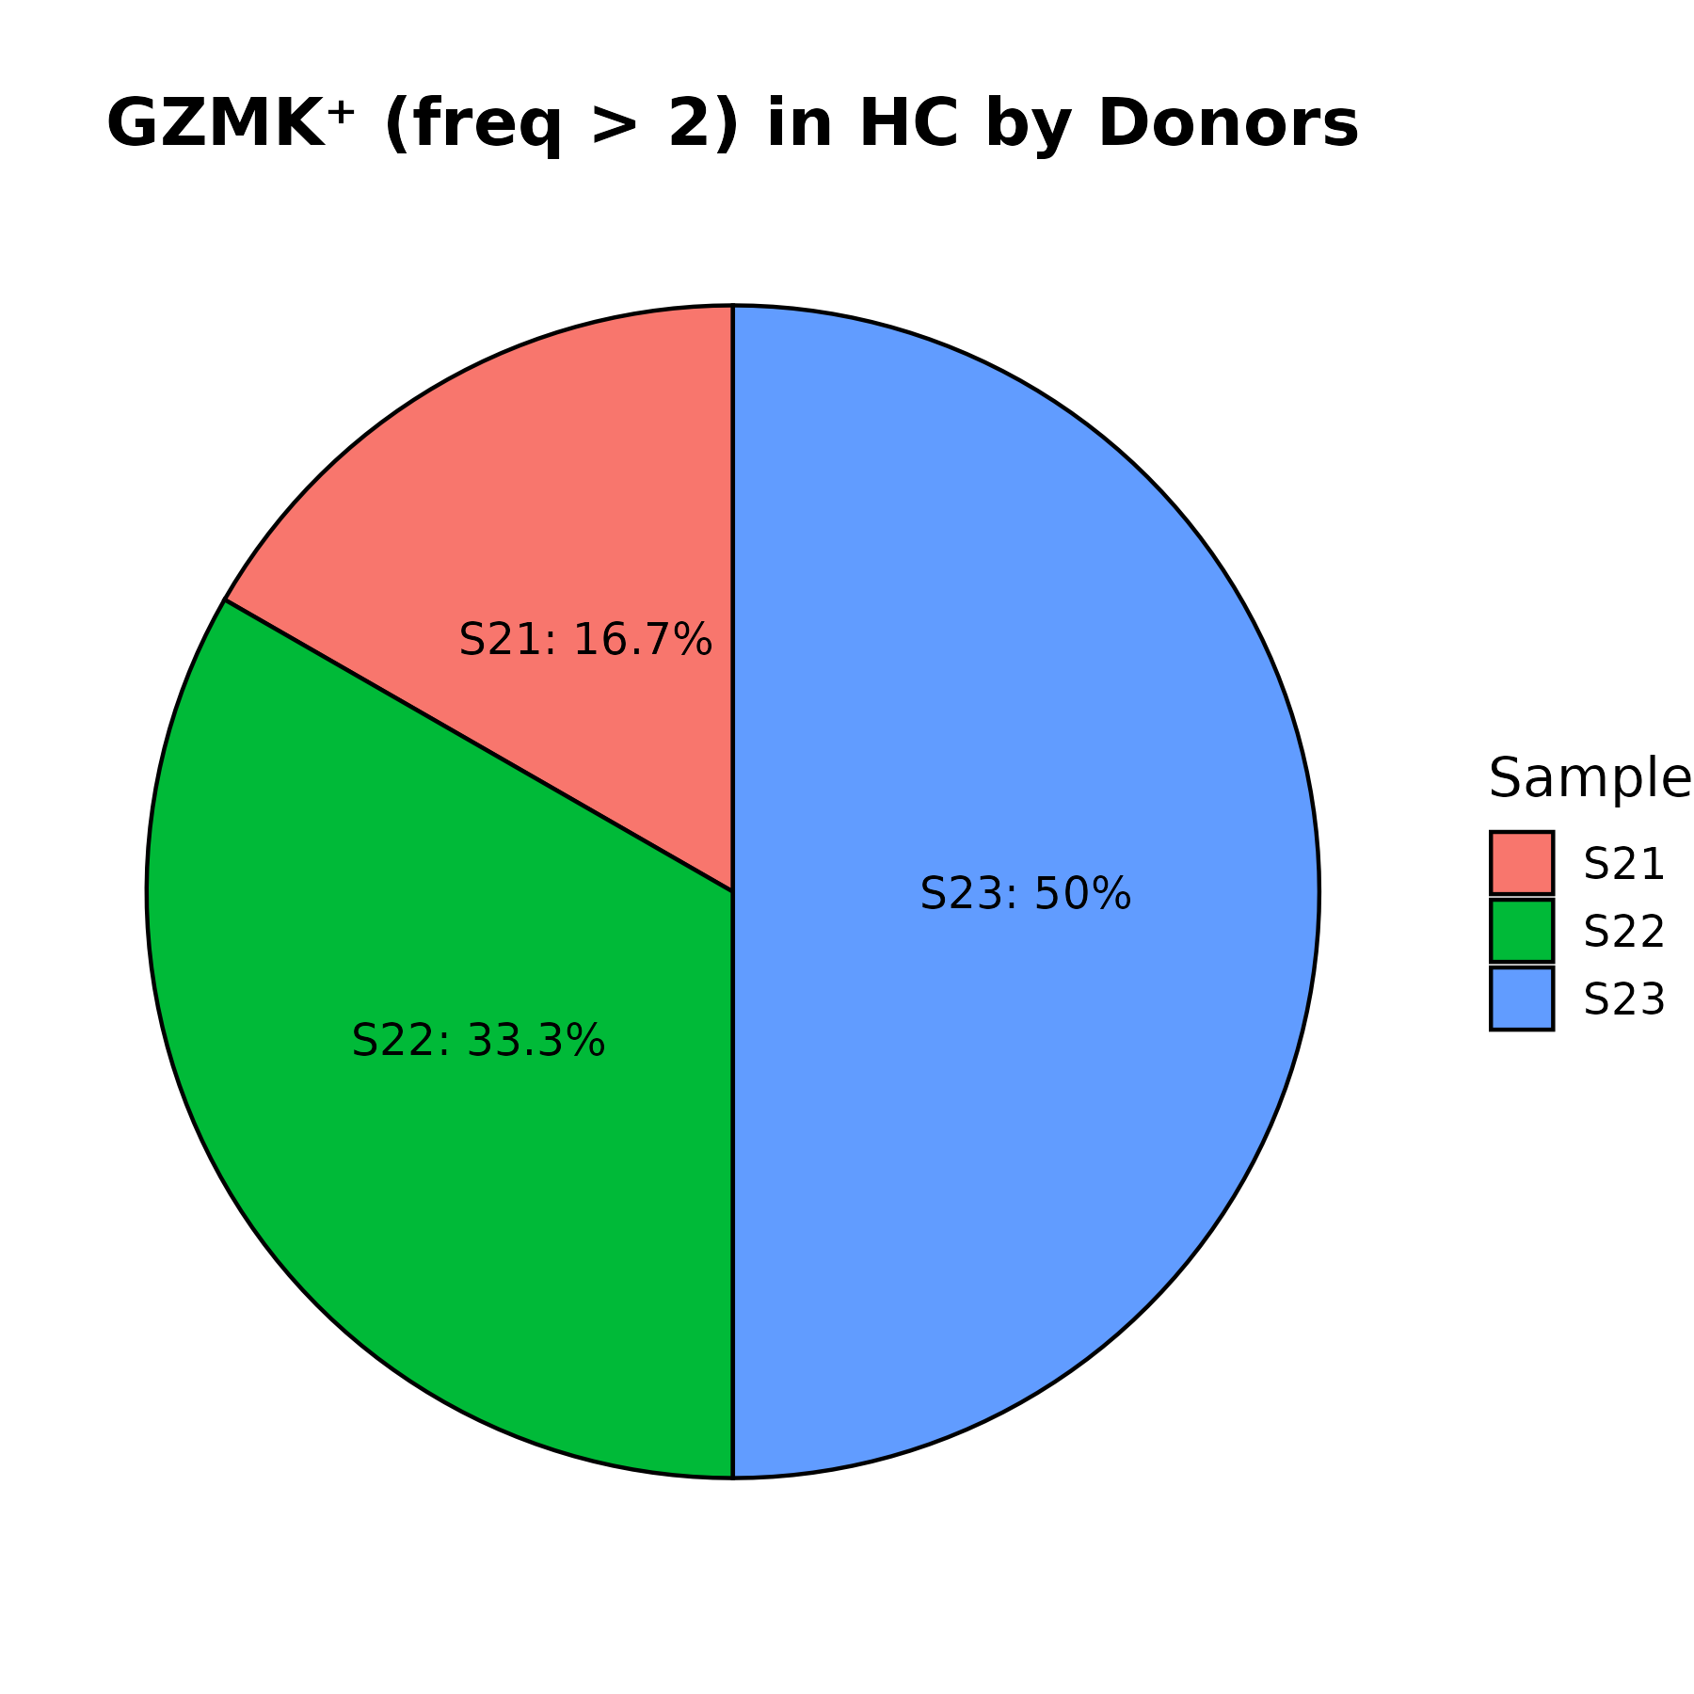
Figure 25A (HC)
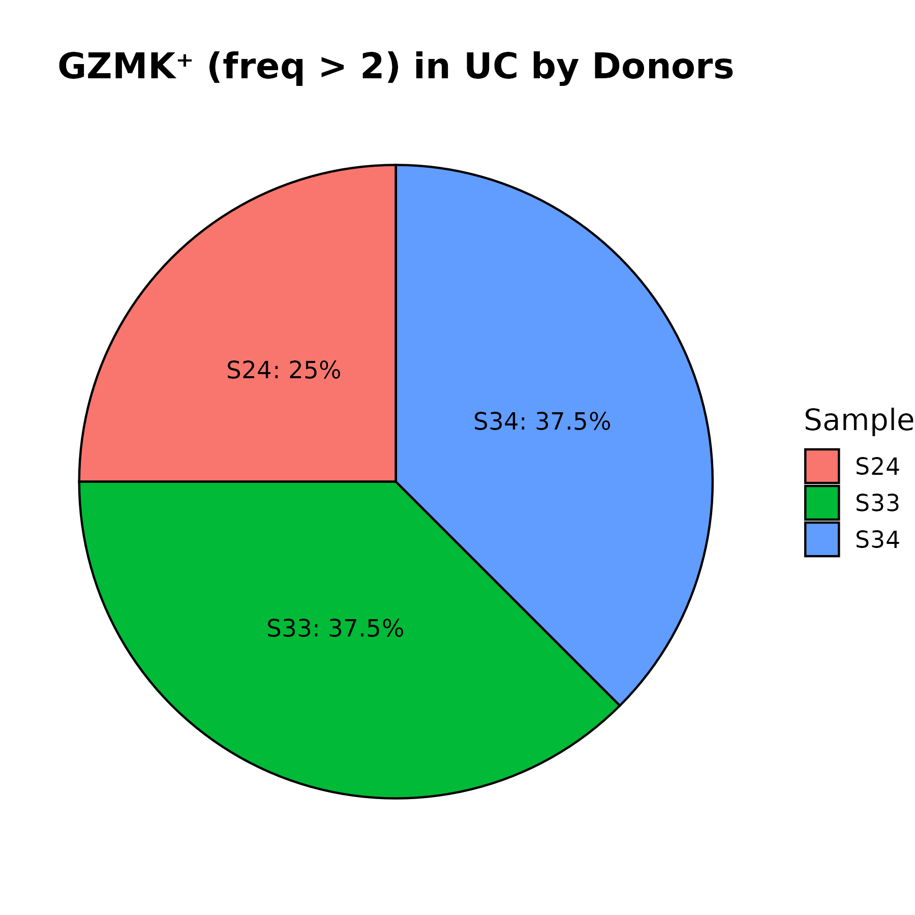
Figure 25B (UC)

Figure 25A (HC):
Pie Chart Showing Donor-wise Distribution of GZMK⁺ Clonal Viral TCR Cells (freq > 2) in Healthy Controls (HC). Red (S21): 16.7%. Green (S22): 33.3%. Blue (S23): 34.5%. Each sector represents the percentage of total GZMK⁺ clonal TCR cells in the HC group attributed to a specific donor.

Figure 25B (UC):
Pie Chart Showing Donor-wise Distribution of GZMK⁺ Clonal Viral TCR Cells (freq > 2) in Ulcerative Colitis (UC) Patients. Red (S24): 25%, Green (S33): 37.5%, Blue (S34): 34.5%

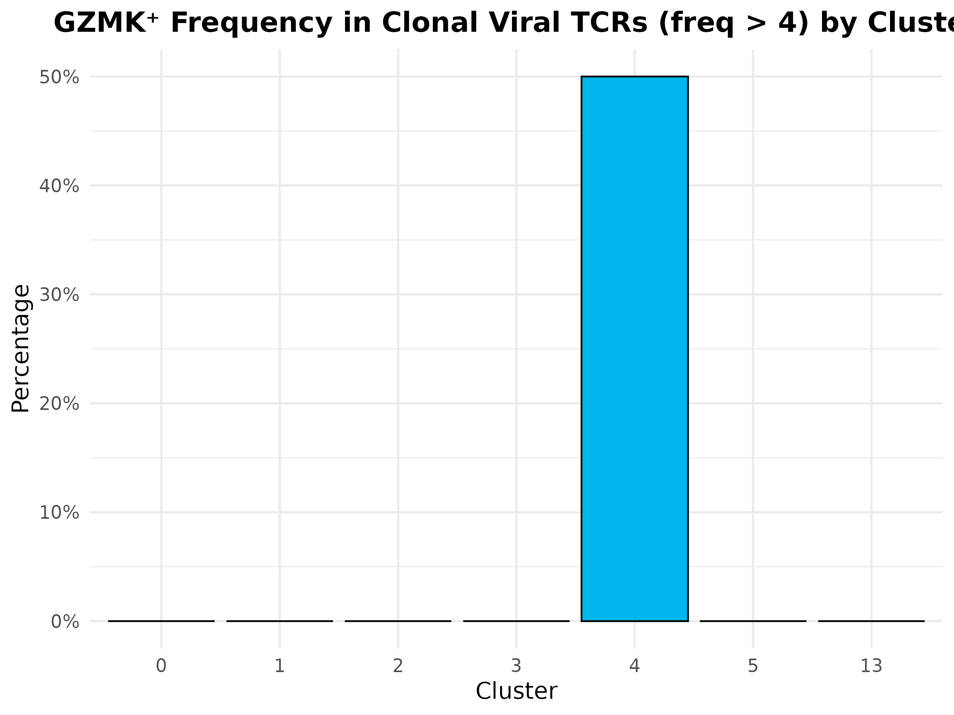

Figure 26A: Cluster-wise Distribution of GZMK⁺ Clonal Viral TCR Cells (freq > 4)
Bar plot illustrating the percentage of GZMK⁺ clonal viral TCR cells (GZMK > 0, clonal expansion frequency > 4) distributed across Seurat clusters (0–13). Cluster 4 shows the highest enrichment (~50%) of these cells. The x-axis represents cluster identity, and the y-axis shows the percentage of total GZMK⁺ cells. Each bar is colored uniquely for visual clarity.

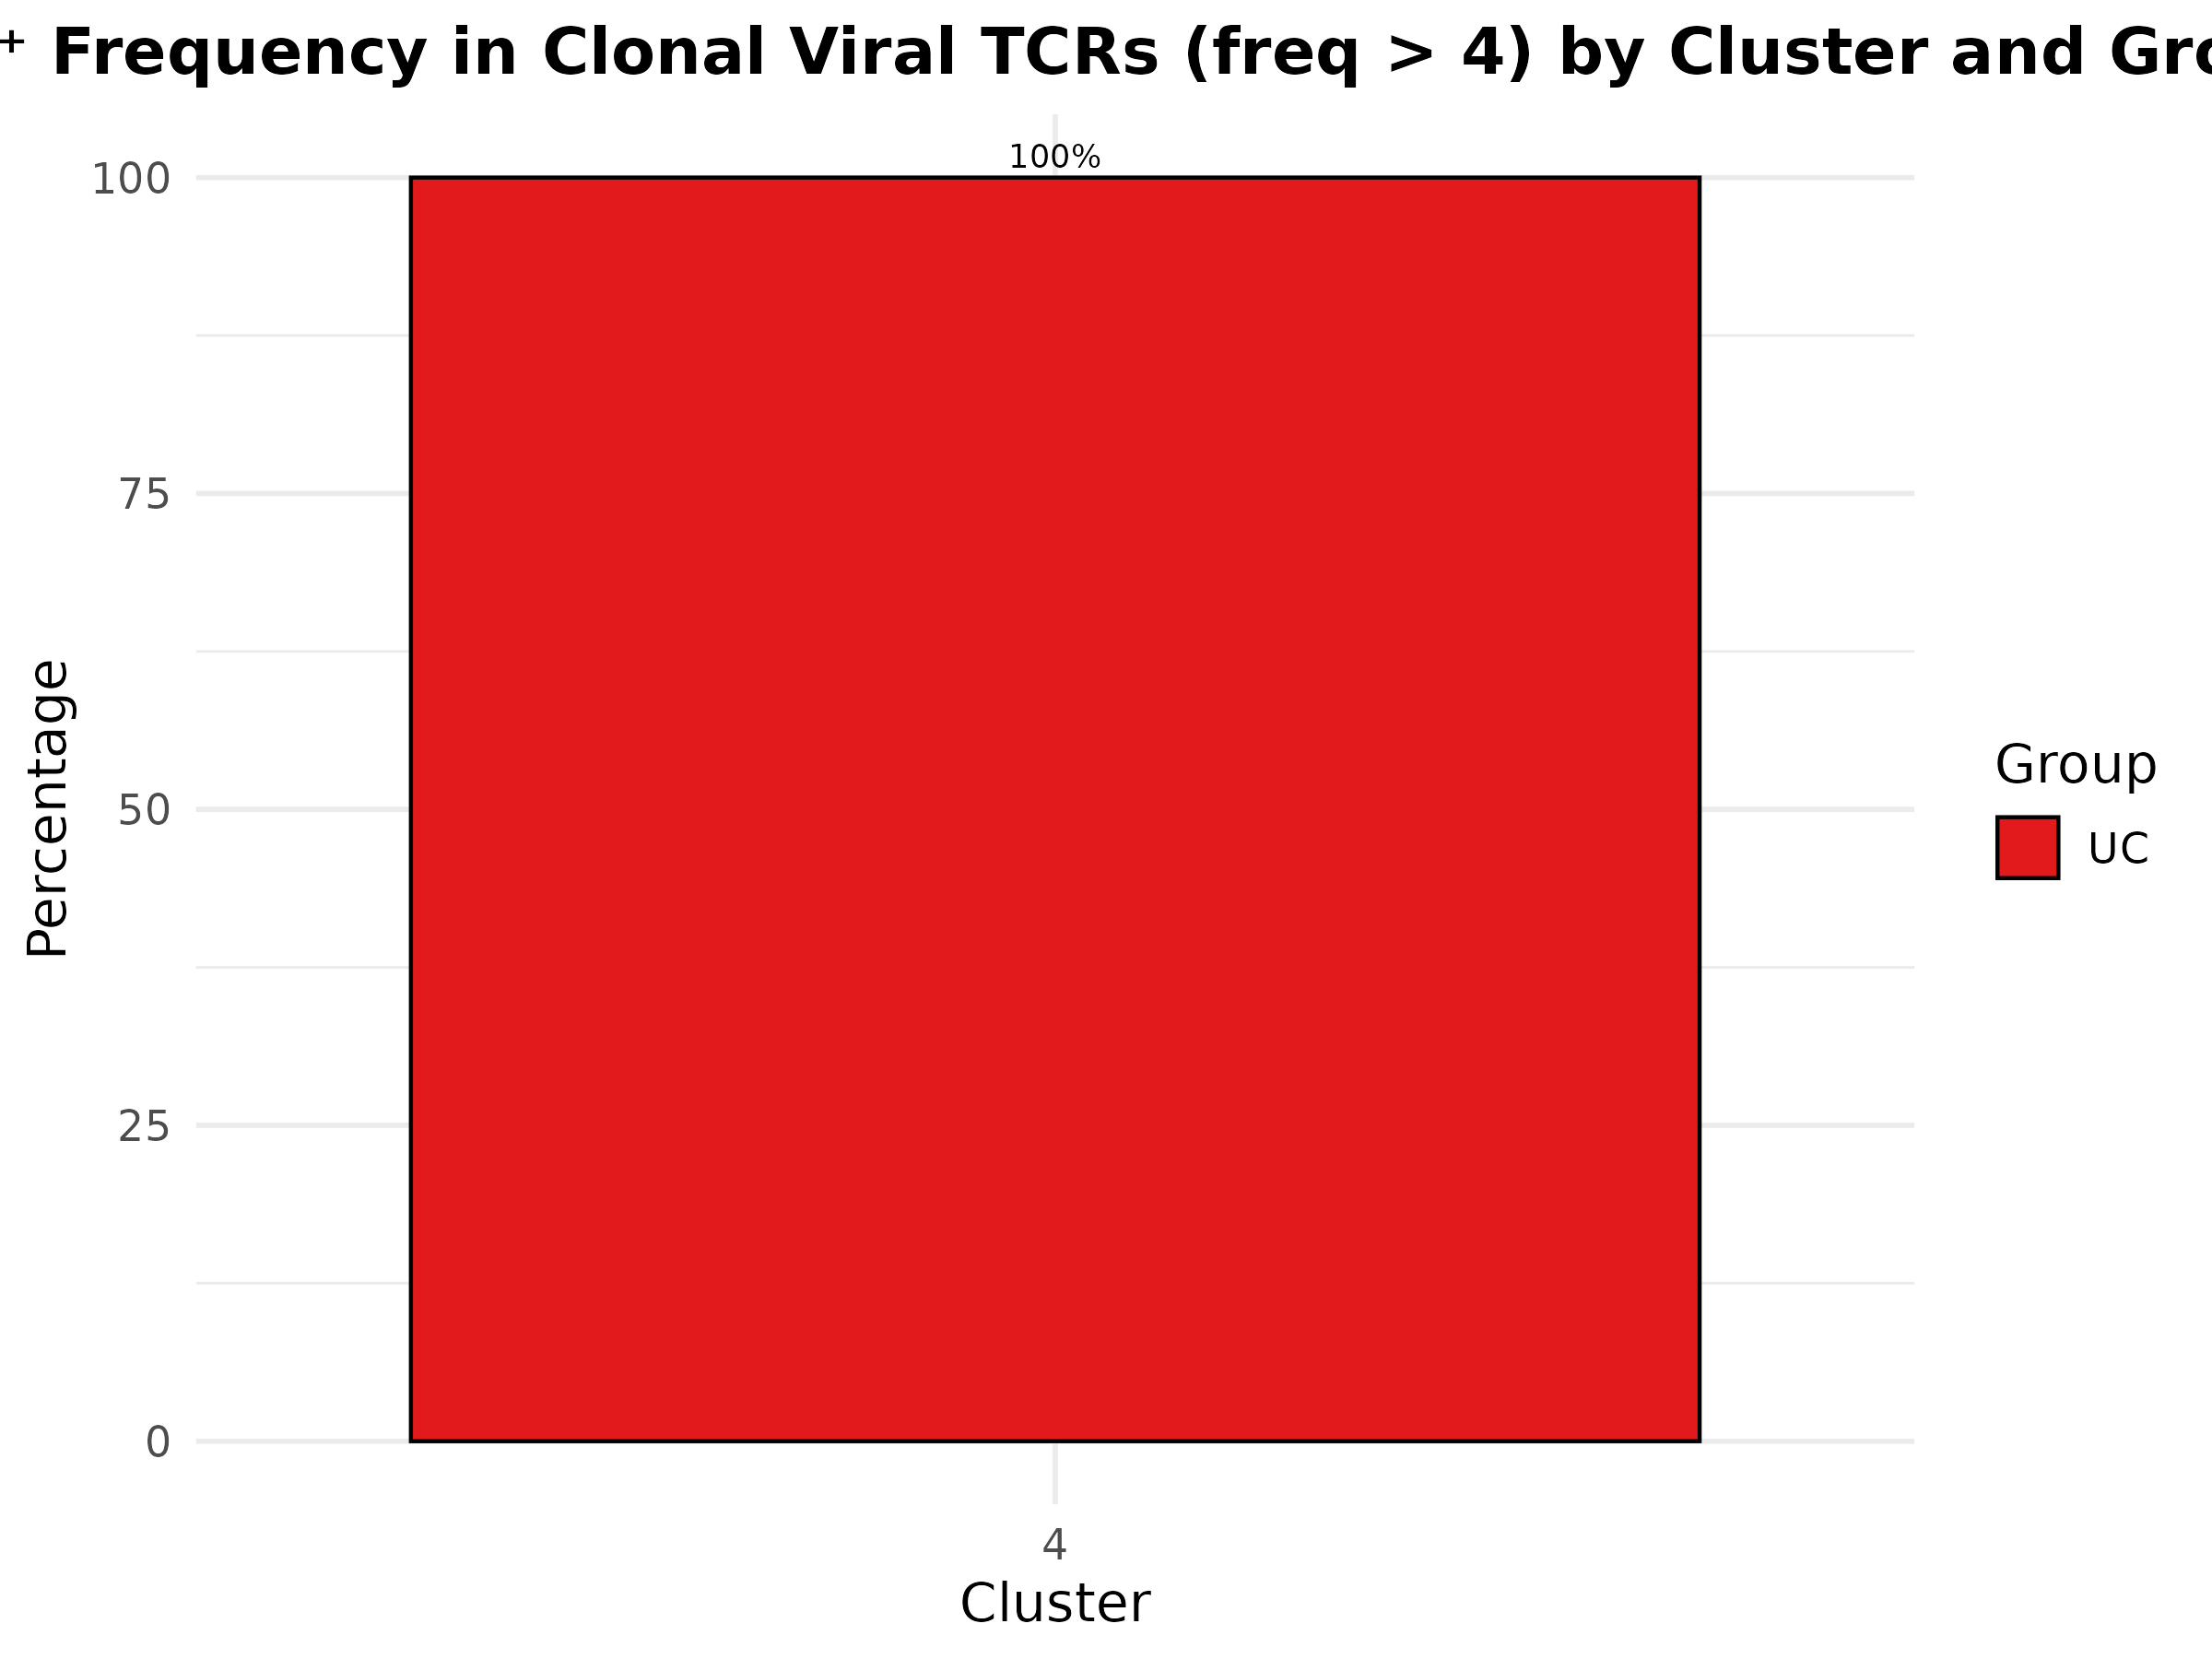

Figure 26B: Cluster-wise Comparison of GZMK⁺ Clonal Viral TCR Cells (freq > 4) Between HC and UC
Grouped bar plot showing the number of GZMK⁺ clonal viral TCR cells (freq > 4) within cluster 4, separated by sample group: Healthy Controls (HC, blue) and Ulcerative Colitis (UC, red). All such cells fall within cluster 4, with UC showing full dominance (100%), indicating a stark group-specific localization.

Short Summary
At a high clonal expansion threshold (freq > 4), GZMK⁺ viral TCR cells were almost exclusively localized to cluster 4, with no substantial distribution across other clusters. Notably, all such cells were found only in UC patients, suggesting a strong disease-specific clonal expansion phenotype. These findings highlight cluster 4 as a key site of enriched effector GZMK⁺ activity during heightened TCR clonality in UC.

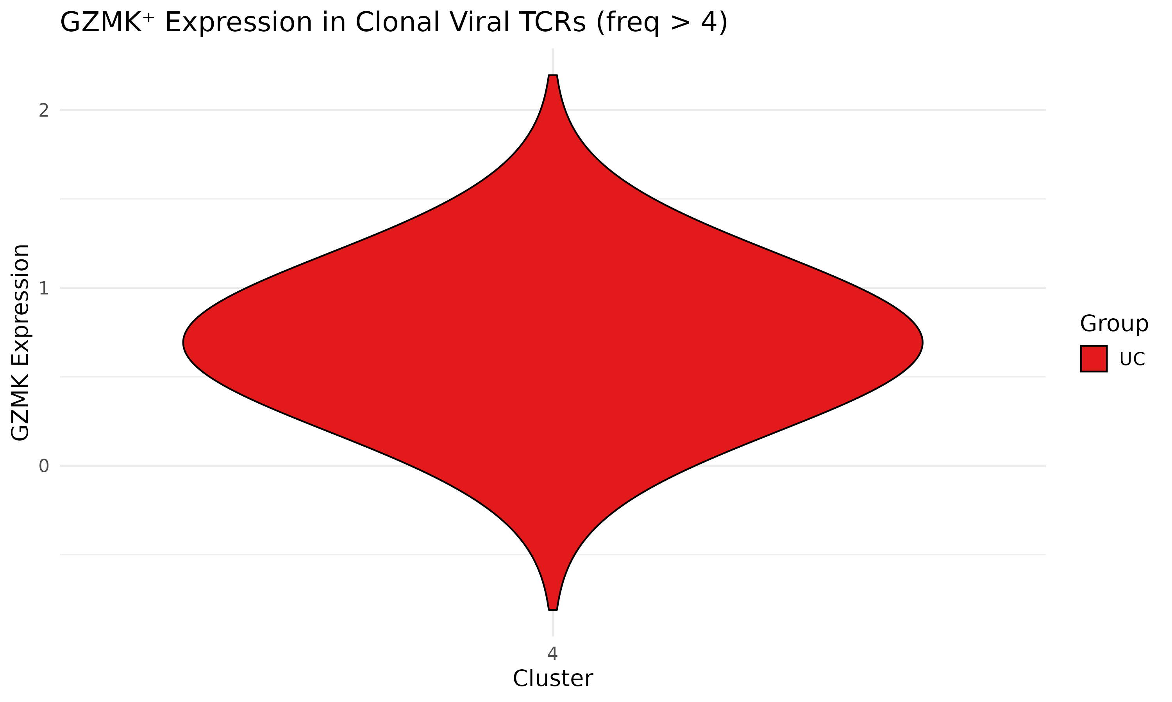

Figure 26C. Violin plot showing GZMK expression in clonally expanded viral TCR cells (frequency > 4) within Cluster 4 for Ulcerative Colitis (UC) patients. X-axis: Cluster ID (only Cluster 4 shown). Y-axis: GZMK expression levels (normalized/log-transformed). Red indicates UC group

Figure 26C. Summary
This violin plot illustrates that within Cluster 4, clonally expanded viral TCR cells from UC donors (freq > 4) show moderate expression of GZMK, with expression values centered around 1. The shape of the violin suggests a relatively narrow distribution, indicating consistent expression levels among UC cells in this cluster. No data from healthy control (HC) donors met the freq > 4 condition for this cluster, and hence are not shown.

